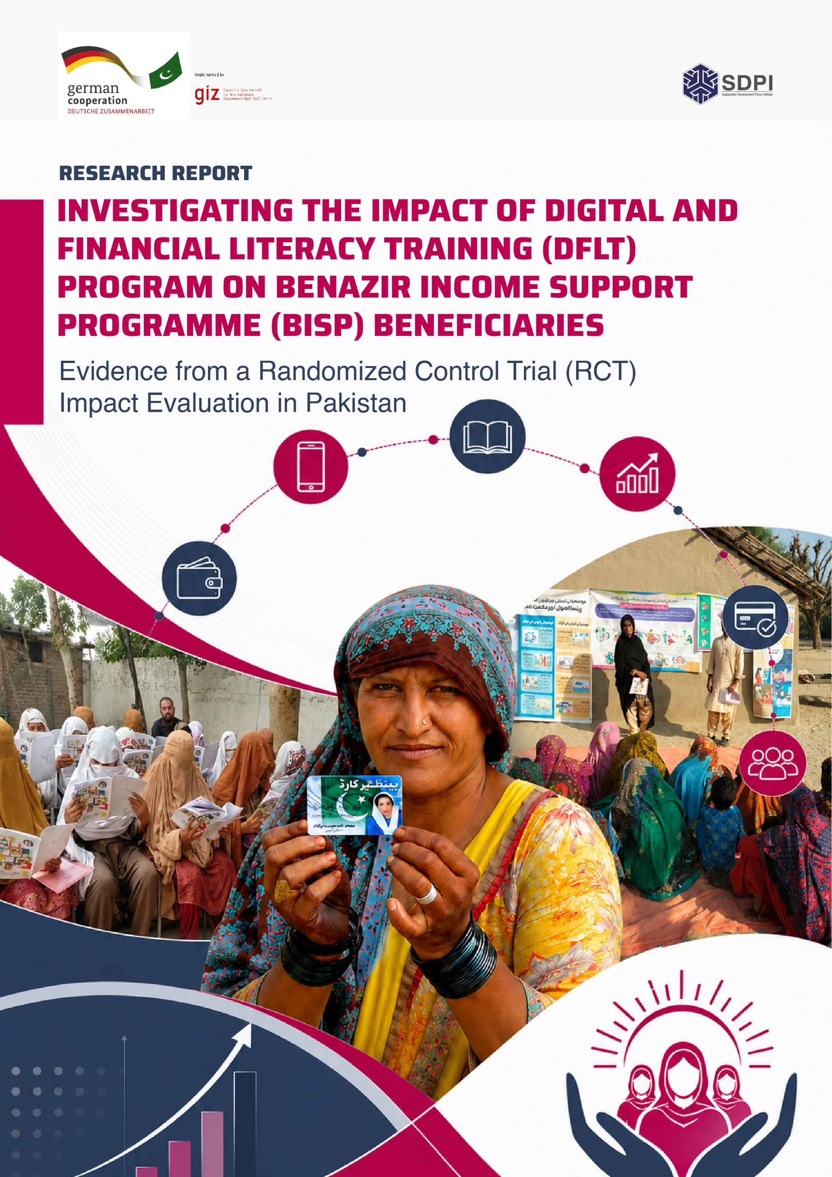

INTRODUCTION
Objectives Of the Study 9
Structure Of the Report 10
LITERATURE REVIEW 12
Meta-Analysis 12
Thematic Synthesis 20
METHODOLOGY 24
Sampling Framework 24
Sample Frame: 25
Sample Size by Technique of Analysis: 25
Phased Interventions for Impact Evaluation 26
Baseline Assessment 27
Monitoring And Evaluation (M&E) 28
Digital Intervention 28
Endline Assessment 30
Conceptual Framework 31
Qualitative And Quantitative Analysis 32
Designing Survey/Study Instruments 35
Definition And Description of the Key Outcome Variables 35
EXPLORATORY DATA ANALYSIS (EDA) 38
Basic Literacy 38
Digital Literacy and Inclusion 40
Financial Literacy and Inclusion 44
Climate Change 51
Birth Registration 56
Gender Equality 57
Key Takeaways from Exploratory Data Analysis EDA 60
QUANTITATIVE RESULTS & DISCUSSION 62
Measuring The Impact of Digital and Financial Literacy Training (DFLT) Program on Benazir Income Support Programme (BISP) Beneficiaries, Using Randomized Control Trial (RCT)- Difference in Difference (RCT-DiD) Technique 62
Impact of DFLT- Results Across Treatment Arms 62
Overall Impact of DFLT: Results Across Key Outcome Variables 67
Disaggregated Impact Analysis/Multilevel Impact Analysis 70
Tehsil Wise Analysis 70
Province Wise Analysis 75
Sub-Group Interaction Analysis- Stratified Results by Age, Education, And Province 80
SOCIAL IMPACT ASSESSMENT (SIA) 83
Impact of Digital and Financial Literacy Training (DFLT): Evidence from Social Impact Assessment- Key Thematic Findings 84
Participant Experiences with the Training 84
Knowledge Gains in Financial and Digital Literacy 84
Behavioural and Attitudinal Change 85
Empowerment, Decision-Making, and Social Norms 86
Persistent Barriers to Impact 87
Differences Between Treatment and Control Groups 88
Provincial Variation in Experiences 88
Insights From Lateral Stakeholders - Community Men & Trainers 88
Trainers Delivering the DFLT Programme 88
Perspectives of Male Household Members 89
Participant Recommendations for Programme Strengthening 90
Key Takeaways from Social Impact Assessment SIA 90
MONITORING AND EVALUATION (M&E) 93
M&E Operational Design and Methodology 93
Process of M&E 93
Parameters Of M&E 96
Key Findings From M&E 97
Challenges and Limitations 104
CONCLUSION 107
Policy Implications 109
REFERENCES 111

LIST OF ABBREVIATIONS
BISP | Benazir Income Support Programme
BoE | Banking on Equality
CAPI | Computer Assisted Personal Interviewing
DFI | Digital Financial Inclusion
DFLT | Digital and Financial Literacy Training
DiD | Difference-in-Difference
DRR | Disaster Risk Reduction
EDA | Exploratory Data Analysis
FGD | Focus Group Discussion
FL | Financial Literacy
GPS | Global Positioning System
HBF | Handbook Format
HSPS | Hybrid Social Protection Scheme
KAP | Knowledge, Attitudes and Practices
KII | Key Informant Interview
KP | Khyber Pakhtunkhwa
M&E | Monitoring and Evaluation
MSME | Micro, Small and Medium Enterprises
NFLP-Y | National Financial Literacy Programme for the Youth
NIBAF | National Institute if Banking and Finance
PDS | Practical Demo Sessions
PKR | Pakistani Rupee
POS | Point of Sale
RCT | Randomized Control Trial
SBP | State Bank of Pakistan
SDPI | Sustainable Development Policy Institute
SEM | Structural Equation Modelling
SHG | Self Help Group
SIA | Social Impact Assessment
WE | Women Empowerment

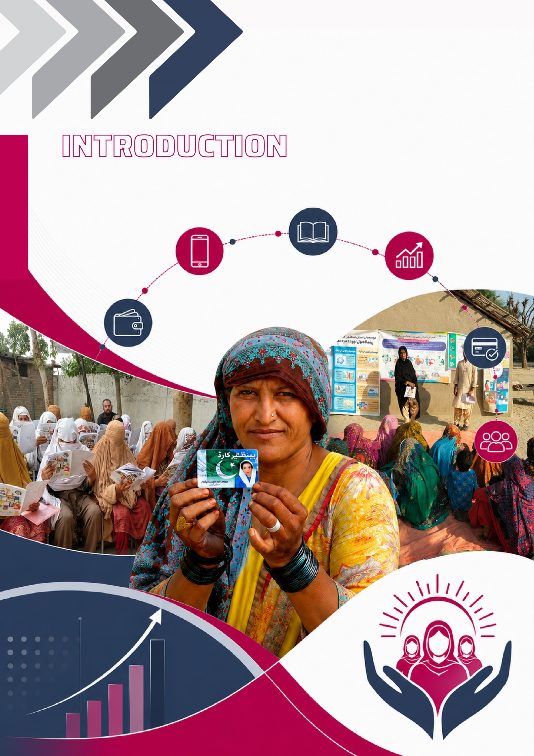

INTRODUCTION
The rapid advancement of digital technologies has fundamentally transformed the way individuals’ access, manage, and utilize financial services. As a result, digital and financial literacy have emerged as essential competencies for fostering financial inclusion, economic participation, and sustainable development. Recognizing this shift, countries across the world are adopting strategic and institutionalized approaches to strengthen digital and financial capabilities through national policies, education systems, and large-scale capacity-building initiatives. The experiences of countries that have successfully integrated digital and financial literacy into their national development agendas offer valuable lessons for designing inclusive and sustainable interventions that empower individuals to effectively participate in an increasingly digital economy.
In the context of developing and emerging economies, community-based models and interventions have been adopted that demonstrate greater outreach as well as viability. For instance, Pradhan Mantri Gramin Digital Saksharta Abhiyan (PMGDISHA) program in India, which was launched in 2017 with an aim to educate basic digital literacy to an individual per rural household, had surpassed its target of training 60 million people by late 2024, with 63.9 million rural been trained. Similarly in Kenya, the M-Pesa has transformed the financial inclusion ecosystem in the country with adoption of mobile money by 96% of households as of 2020 (Mulili, 2022). In addition to this, research conducted by (Suri & Jack, 2016) revealed that the programme had managed to uplift an estimated 194,000 households (approximately 2% of Kenya households) out of extreme poverty. This highlights the broad and multifaceted role of Digital and Financial Literacy which transcends poverty alleviation, digital empowerment, and inclusive growth.
While the new technologies are revolutionizing the access of financial services to poor and underserved communities across the world. Following this, the role of financial institutions (both banks and non-bank) is transformative, as it introduces new services and products that not just enhance access to finance but also traverse missing links in the access chain. Despite this, the figures by (World Economic Forum, 2024) depicts the huge gap in financial inclusion especially in developing economies, with 1.4 billion people not having access to financial systems worldwide. The gap is even more prominent in Pakistan with already having a low percentage of the population with access to finance and the pertinent gender gap in the financial inclusion. This low level of financial inclusion is largely attributed to the low level of financial awareness of financial products and their utilization, referred to as financial literacy.
Recognizing the dire need of enhancing Financial Literacy (FL) of the general population, the State Bank of Pakistan (SBP) introduced an initiative to support and enhance the financial literacy ecosystem within Pakistan. Consequently, two programmes were introduced over the last decade, i.e., a National Financial Literacy Programme to the middle-income households all over the country - implemented by State Bank of Pakistan; and the National Financial Literacy Programme to the youth (NFLP-Y) which has beenimplemented by National Institute of Banking and Finance (NIBAF). The National Financial Literacy Programme is carried out in a phased approach to teach the basic concepts of finance, financial products and services and cultivate practical skills, such as budgeting, saving and dealing with debt. It also fosters the changes of behaviours leading to improvement in financial wellbeing since it involves improved decision making, stress levels and confidence. On the other hand, the National financial literacy Programme for Youth (NFLP-Y) focuses on young people and school going children of Pakistan, categorized into three groups 9-12 years, 13-17 years, and 18-29 years with an aim of enhancing their money management skills and enhancing their understanding of financial matters. Apart from providing training to youth, the key concepts of financial literacy have also been incorporated into the primary level curriculum under the NFLP-Y.
As per the estimates provided by (SBP, 2025), the 3.4 million of the total population that has received the training under National Financial Literacy Program for Adults and Youth with women making up 58 percent of total participants. Furthermore, the initiatives such as RAAST, Asaan Digital Account and Asaan Mobile Account have also been quite prominent in leveraging the secure, digital and cost friendly means of access to financial services. According to the third edition of National Financial Inclusion Strategy NFIS (2024-2028), the SBP aims to raise financial inclusion in the country to 75 per cent with subsequent narrowing of the gender gap to 25 per cent (SBP, 2024). Here, the strategy prioritizes enhancing the capacity of both the institutions and the people, especially the underserved and the marginalized communities of the society such as women, youth and the disabled. Following the undertaken initiatives, (SBP, 2024) reports that Pakistan has experienced a leap of its financial inclusion up to 64 percent in 2023, which was 16 percent in 2015
Despite all these programs, there are persistent gaps for the bottom of the pyramid and particularly the poor and vulnerable women in terms of both financial inclusion and digital readiness. For addressing this challenge, BISP (Benazir Income Support Programme), the largest social safety net in Pakistan launched a thoughtful initiative in the form of Digital and Financial Literacy Training DFLT for its beneficiaries. The women who are enrolled under the umbrella of BISP beneficiary’s are mostly uneducated, marginalized, and disadvantaged segments of the society. BISP beneficiary women have low levels of not just digital and financial literacy but also general literacy, so a strong emphasis on communication, messaging and awareness was considered an essential component of these trainings. Furthermore, during the training, beneficiaries have been trained to operate basic accounts and access formal financial services. The financial literacy training provided information on the importance of opening an account/ a mobile wallet, the benefits of retaining funds in that account and the convenience of using that account for digital transactions. It also taught women the skills and tools for effective financial planning and decision making, increasing their financial options through access to appropriate credit and savings products, and subsequently paving the way for their financial inclusion.
Furthermore, it leveraged an additional video intervention in which the set of animated educational videos on the same topics that were covered during the training were sent to the cohorts of targeted beneficiaries via the medium of WhatsApp. This intervention offered them a convenient and flexible opportunity to re-learn and reinforce the important concepts at their own pace and ensure long-term knowledge retention. Overall, DFLT Phase seamlessly aligns with the evolving needs of BISP beneficiaries, particularly in addressing the prevalent issue of financial illiteracy among women. The Project is poised to significantly enhance the empowerment and well-being of the beneficiary community.

Objectives Of the Study
The objectives of the study are as follows;
- Analyze the impact of financial literacy training on the behaviour of targeted BISP beneficiary households.
- Identify and highlight the primary channels through which financial literacy training has influenced household behaviour, including aspects such as consumption, saving, and investment.
- Evaluate the extent to which the utilization of financial products (cheque, ATMs, etc.) can be attributed to the financial literacy training.
- Assess the resonance of specific modules within the financial literacy training among beneficiaries.
- Identify any redundant training modules based on their relevance and content from the perspective of the beneficiaries.
- Measure the level of knowledge retention among the target audience who have undergone financial literacy training.
- Examine if there has been any improvement in economic indicators within the households of the target audience.
- Investigate whether the status of women account holders has improved within their households and communities.
- Explore the possibility of segmenting the target audience based on the evaluation exercise and propose criteria for economic empowerment.
- Provide recommendations for enhancing the training content and instructional methodology, considering the insights gained from the impact evaluation, to facilitate the national-scale implementation of the financial literacy initiative.

Structure Of the Report
The structure of the report is as follows. The Introduction provides the background, context, and objectives of this study and explains its significance. Chapter 2 provides the Desk Review from the existing body of literature in this area and positions on how this study can valuably contribute to the field of knowledge. Chapter 3 describes the Research Methodology, including the Sampling procedure and Sample size, Data collection, Conceptual framework and Analytical technique applied. Chapter 4 presents the main preliminary findings using Exploratory Data Analysis EDA. Chapter 5 discusses the main Empirical findings for the Impact Evaluation of the DFLT on the BISP beneficiaries employing Randomized Control Trial (RCT) and the RCT Difference-in-Difference (RCT-DiD) technique. Chapter 6 draws on the Qualitative insights on the impact of DFLT through Social Impact Evaluation (SIA). Chapter 7 discusses the observations and takeaways from subsequent and robust Monitoring and Evaluation (M&E) of the DFLT. Lastly, Chapter 8 summarizes the report with conclusion and puts forth a set of policy recommendations, considering the insights gained from Impact Evaluation to facilitate the future programming.
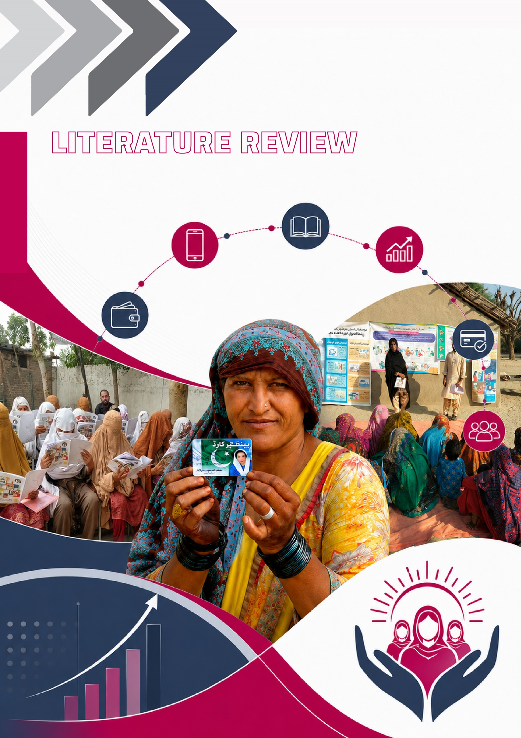

LITERATURE REVIEW
This chapter entails the review of the literature to deepen the understanding of existing work on the importance of Digital and Financial inclusion and Digital and Financial Literacy in accelerating socio-economic development. This review is structured into two segments; i-e Meta-analysis and Thematic synthesis, to present a comprehensive and coherent assessment of the prior studies. The literature consistently identifies financial inclusion and digital and financial literacy as foundational drivers of inclusive and sustainable economic growth.

Meta-Analysis
Table 1: Summary Synthesis of Included Quantitative & Qualitative Studies
Study | Training Focus | Country | Dimension of Outcome | Study Design |  |  | Brief Findings
Koomson et al. (2020) | 2-day financial literacy training for low-income households that are beneficiaries of NRGP, RTIMP and REP. | Ghana | Financial Inclusion |  | Quantitative; RCT Randomized Control Trial |  | The financial literacy training significantly impacted the account ownership, saving behaviour and access to financial assistance. The results showed the intensity of financial inclusion among the beneficiaries.
Kahina et al. (2024) | Digital and Financial literacy training to Micro, Small and Medium Enterprises MSME and local community | Sorong City, Indonesia | Economic Empowerment and Market Access |  |  | Mixed Method; Quantitative and Qualitative | The results showed improved economic independence of the participants especially MSMEs, by ensuring better understanding of financial and digital skills. It also helped improve the access to market and information networks.
Calderone et al. (2018) | 2-day financial literacy training to low-income branchless banking users in India | Uttar Pradesh, India | Saving behaviour, Budgeting skills and overall financial knowledge and attitude |  |  | Quantitative; | The key findings suggest that the intervention significantly improved the saving behaviour of treatment group with reduced spending on temptation goods.
 |  |  |  |  |  | Randomized Experiment
Mishra et al. (2024) | Digital and financial literacy training to women employed in SHGs, MSMEs, healthcare and educational institutions | Uttarakhand and Uttar Pradesh,India | Promote digital and financial literacy, fintech adoption, financial decision making (investment intent) |  |  | Quantitative; Structural Equational Modelling SEM | The findings revealed that digital literacy improved the financial decision making of women and exerted robust effect on the intention towards investment.
Karki et al. (2024) | Financial literacy training implemented by (SaMi) to rural households. | Bhojpur District, Nepal | Financial decision making and economic behaviour |  |  | Quantitative; Cross sectional; Multiple regression model | The training had positive and significant impact on the financial literacy levels and economic decision making of the rural households. However, the impacts are also mediated by other demographic characteristics of participants.
Custers (2011) | Samhita financial literacy training program targeted at economically disadvantaged and poorly literate women | Bhopal, India | Improved financial literacy levels |  |  | Quantitative; RCT Randomized Control Trial | The study found positive and significant effect of training on the financial literacy levels of the treatment women.
Proscovia et al. (2021) | Informal financial literacy training to smallholder rural farmers that are members of village savings and loan associations (VSLA) | Uganda | Financial Knowledge and Behaviour (financial inclusion) |  |  | Quantitative; Cross Sectional; Propensity Score Matching and Focus Group Discussions | The findings indicate improved financial knowledge and subsequent behaviour towards saving, planning and managing financial shocks. However, the gains are modest across treatment and control group which is attributed to spillover and diffusion effect through peer network.
Steinert et al. (2018) | Financial literacy training integrated into broader psychological parenting intervention targeting low-income caregivers across rural and peri-urban settlements | South Africa | Economic resilience and empowerment |  |  | Quantitative; Cluster RCT | The results showed improved financial behaviours with increased savings and reduced borrowing rates. It also indicates the impact of psychological intervention on reduced financial distress and improved economic welfare and resilience.
Koomson et al. (2023) | 2-day financial literacy training for low-income households that are beneficiaries of NRGP, RTIMP and REP. | Ghana | Financial asset accumulation (savings, account holdings) |  |  | Quantitative; Randomized Experiment | The results showed that financial literacy training significantly increased the accumulation of productive assets among female headed beneficiary households. It also improved the account holdings with large impact on male.
Koomson et al. (2021) | Joint financial literacy and women empowerment training targeting female and young household heads. This treatment group is beneficiary of NRGP, RTIMP and REP. | Ghana | Household consumption and welfare |  |  | Quantitative; | The findings revealed that impact of intervention on household consumption is influenced by design and delivery of programme. As the beneficiary who received both FL and WE training showed notable improvement in household consumption as compared to those who had just received either FL or WE training.
 |  |  |  |  |  | Randomized Control Trial
Qudsi & Nurhayati (2023) | Basic Financial literacy training for rural family heads and community members in Cidaun, Cianjur district | Indonesia | Community empowerment/resilience and financial awareness |  |  | Qualitative; descriptive, in-depth interviews and non-participative observation | The study found improved basic financial literacy and awareness among the community. The training equipped and empowered the community with the basic skills required for managing daily financial matters and engage in rising digital economy.
Kumar & Shobana (2025) | Basic digital literacy training to rural citizens and entrepreneurs in districts of Nagaland. Total of 20 hours trainings spanning 10-30 days combining online and offline modality. | Nagaland, India | Digital awareness |  |  | Mixed method; | The results showed PMGDISHA significantly influences the digital awareness and financial inclusion among the rural population. The improved level of awareness greatly enhances the participation in e-commerce and e-transactions.
Kumar & Shobana (2025) |  | Nagaland, India | /empowerment, financial inclusion and socio-economic development |  |  | Quantitative and
Kumar & Shobana (2025) |  | Nagaland, India |  |  |  | Qualitative
Rajeev et al. (2018) | Basic Digital Literacy training courses for non-IT literate individuals Kalliyoor Panchayath, Thiruvananthapuram District. | Kerala, India | Digital awareness & empowerment, skill development |  |  | Quantitative, Exploratory | NDLM trainings showed to empower the non-IT literates from the study districts. The digital awareness boosted the participant confidence in usage of basic tools and e-services.
Singh (2024) | Workshops, technical sessions and field level handholding aimed at promoting digital literacy and empowerment initiatives for rural women. | India | Digital and financial inclusion, socio-economic empowerment of rural women |  |  | Qualitative, case study and review of program outcomes | PMAGY greatly worked to enhance the e-service delivery to the rural women in terms of governance and agricultural equipment, which in turn enhanced their participation in the community decision-making process and income-generating activities.

Thematic Synthesis
Financial inclusion through providing access to financial services, especially to the underprivileged class, is considered to be a powerful instrument in accelerating socio-economic development. The advent of digital financial technology has greatly widened the scope of financial inclusion, making it even more convenient. There is substantial literary body of evidence globally that affirms the pivotal role of financial inclusion as key driver of socio-economic well-being. The literature dates back to the early work by Mass and Kumar (2008) that signifies the importance of mobile phones making financial services accessible to underserved populations through low-cost models. Their work explains how mobile banking increases financial inclusion which in turn fosters economic development. Another study by Jack and Suri (2011) provides earliest empirical findings that signifies the positive impact of digital financial inclusion on economic development. They concluded that the introduction of M-PESA in Kenya has significantly evolved financial behaviours by decreasing transaction costs and making financial services more accessible.
However, recent studies in the literature provide more promising empirical findings on the impact of digital financial inclusion on socio economic development. A recent cross-sectional study (Yakubi et al. 2022) across 77 low-income countries posits financial inclusion as the instrumental driver of socio-economic development and poverty reduction by ensuring an equitable and adequate access of digital financial services to all segments of society. Further, a systematic literature review by (Mishra et al. 2024) also provides evidence on financial inclusion as a powerful catalyst for socioeconomic development, influencing various aspects such as poverty reduction, economic growth, gender equality, financial literacy, entrepreneurship, social stability, innovation in financial services and women empowerment.
Showkat et al. (2024) investigates the area deeply from a gender equality perspective by exploring significant association between financial inclusion and economic empowerment of women in India, highlighting financial inclusion as the prerequisite of sustainable development. Their findings reveal a positive significant impact of financial inclusion on women’s earnings, savings and asset accumulation in the pursuit of economic well-being. These findings are backed by Mabrouk et al. (2023) through another comparative study conducted in post COVID-19 pandemic era, that access to digital and financial services strongly and positively influence the women’s economic autonomy and their ability to make informed decision post COVID-19 pandemic era (Mabrouk et al. 2023).
Basnayake et al. (2024) provided evidence-based implications that Digital Financial Inclusion, DFI is imperative to inclusive growth, and the FinTech (financial technology) as the most viable and efficient solution aimed at poverty eradication and fostering women empowerment in low-income countries (Babar, 2023). Consequently, with evolving technological sphere, the synergy of digital inclusion and financial inclusion emerged as a transformative force. In this regard, (Dhungana, 2022) conducted systematic literature review focusing on South Asian countries. His study concludes digital innovation and technology as a significant driver of financial inclusion. He further stresses the need to take measures for implementing strategies for financial inclusion of underserved, marginalized and low-income individuals.
Amidst the evolution and widespread significance of digital and financial inclusion, strengthening the Digital and Financial literacies also emerged as the key priority. Kass-Hanna et al. (2022) conducted research in South Asian and Sub-Saharan African Countries and found that both financial and digital literacy are vital for building inclusive and financially resilient societies by positively influencing the financial behaviours such as saving, borrowing, and risk management. However, this relationship varies across different regions and demographic groups. Kumar & Jie (2023) builds that financial inclusion is more effective in reducing poverty when women and the poor have better access to formal financial services. However, high income and gender inequality, poor institutional quality, and low educational attainment greatly undermine its effectiveness.
Mwanza & Odoyo (2024) conducted an impact evaluation study on traditional financial inclusion models in rural Zambia and found that traditional banking services, mobile-based solutions, and community-driven initiatives are not effective in long run if implemented in silos and they must be integrated with financial literacy programs. Similar, impact assessment of Pradhan Mantri Jan Dhan Yojana (PMJDY) (India’s flagship financial inclusion initiative launched in 2014) was conducted by (Vinod, 2025) and found its substantial impact on financial inclusion particularly benefitting women and marginalized communities. Yet the program effectiveness was largely hindered by lack of digital infrastructure.
In the context of Pakistan, there is a growing body of scholarly work that increasingly explores the nexus of Digital and Financial inclusion, literacies and economic well-being of the individuals. Mahmood et al. (2023) showed with empirical evidence that financial inclusion fosters inclusive economic growth, thereby contributing to poverty alleviation in Pakistan with financial literacy reinforcing the strength of relationship between the two. Saeed et al. (2024) found the same, and emphasize the need for the targeted educational programs, having established the direct link between financial literacy and economic well-being.
Ejaz & Qayum (2023) corroborates a bidirectional relationship between financial inclusion and women’s empowerment, reinforcing each other and implying strengthening educational opportunities, technological capabilities and access to phone as crucial components to financial inclusion. Another study established that greater level of financial literacy among women will leads to improved access and utilization of financial services, financial inclusion, which in turn will enhance the women economic empowerment in Pakistan (Nawaz et al. 2023).
The literature reviewed above provides substantial evidence on the role of digital and financial inclusion in advancing socio-economic development, while also highlighting the need for continued research, policy, and program innovation to expand such initiatives. It provides a comprehensive understanding of the established narratives through structured Meta-analysis and Thematic synthesis. The Meta-Analysis consolidates the findings from both quantitative and qualitative studies evaluating various digital and financial literacy programs across diverse global contexts. Some of these studies capture the impacts at the macro level, like the women's economic empowerment, role in overall economic growth, and development, while the others focus on the micro level impact, such as individual financial knowledge, behavioural change, saving and investment patterns and the household decision making. whereas the Thematic synthesis offers a broader and Evidence-based perspective, demonstrating that financial inclusion, complemented by digital and financial inclusion, consistently emerges as a critical driver of economic empowerment, gender equality, poverty reduction, and the overall economic well-being.
Despite this growing evidence, a notable gap persists in assessing the individual-level impact of such programs and interventions, with a particular focus on the marginalized women in the developing country context, like Pakistan. Specifically, there is limited empirical work examining how training interventions translate into changes/improvement in individual knowledge and subsequent behaviours and actions. This dearth in exciting research is central to the motivation of the present study, which aims to generate the context-specific evidence on the micro-level impact of the Digital and Financial Literacy Training (DFLT) on the BISP beneficiary women in Pakistan.

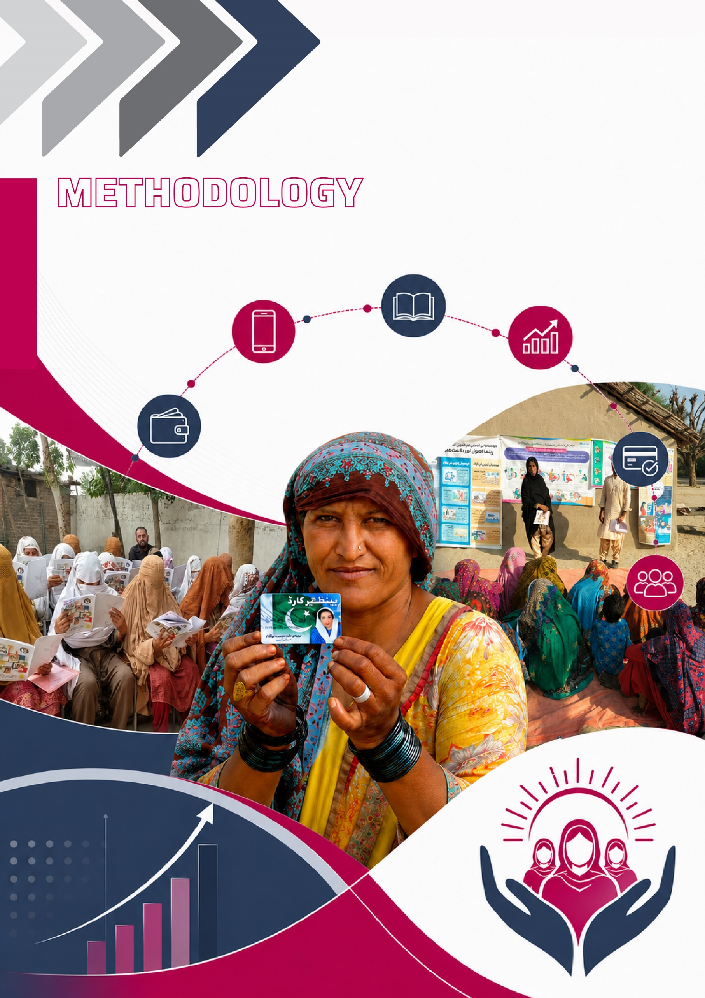

METHODOLOGY
This chapter entails the phased methodological approach used in this study, primarily focusing on the Sampling frame and Techniques applied for Qualitative and Quantitative analysis that measures the effect of Digital and Financial Literacy Training (DFLT) on BISP beneficiary woman outcomes. Section 1 starts by presenting the sampling framework adopted for this study. Section 2 provides a detailed breakdown of the phased interventions/approaches undertaken during the impact evaluation study. Section 3 conceptualizes the channel through which the impact is delivered. Section 4 outlines the main Quantitative and Qualitative approaches employed for the analysis of the data collected. Then, Section 5 sets out the designing of the Survey instruments used for the structured surveys, KIIs and FGDs. Finally, Section 6 provides the definitions and the description of the key outcome variables observed in the study

Sampling Framework
Here is the delineation of the generalized framework utilized for the sample estimation of the study. The various interventions for the study were administered exclusively to the BISP beneficiaries of 08 districts across Pakistan. A key selection criterion was that beneficiaries must have participated in the BISP program for minimum of two years to ensure their eligibility and availability for both the baseline and endline survey.
For this purpose, it employed a three-stage cluster sampling technique with the subsequent random sampling at each stage of selection. The figure below depicts the administrative hierarchy in the country. Four provinces, including Punjab, Sindh, Khyber Pakhtunkhwa (KP), and Baluchistan, were selected for the study. Within each province, the districts were selected, followed by the random selection of the tehsil within each district. Finally, beneficiaries within each tehsil were randomly sampled for inclusion in the study.
Figure 1: Process of Selection of Beneficiaries:
- 04 Provinces (Punjab, KP, Sindh, Balochistan)
- 02 District from each Province
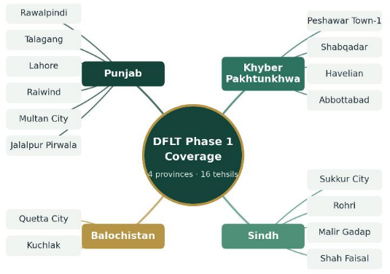
  - 02 Tehsils from each district

The sample selection of the respondents is as follows:
A multistage (three-stage) cluster sampling process is performed within each stratum to concentrate resources in fewer places.
- The 1st stage of cluster sampling involves random sample of 08 selected districts nationwide.
- The second stage of cluster sampling involves randomly selecting tehsil from each district.
- The third stage of sampling involves a random sample of number of beneficiaries from each tehsil.

Sample Frame:
The number of beneficiaries from each tehsil were selected employing the Random sampling methodology. Given the large population size of the trained beneficiaries, approximately 250,000, a random sampling methodology with a focus of 2% sampling fraction was applied, resulting in a population representative sample of 5000 beneficiaries. This proportion was applied to ensure the sample size remains manageable and statistically meaningful, considering the large sample size.
The sampling process began with obtaining a comprehensive list of eligible beneficiaries, segmented by district and tehsil. Moreover, a larger number of districts will be thinning the sample, making within sample comparisons less reliable. The within sample analyses is very important for impact evaluation as it affects the choice of region and type of interventions which in turn may affect the outcomes of the RCT study. The generalization issues may occur if the sample is too scattered and thin. While the random selection ensured that every individual had an equal chance of being included, thereby minimizing selection bias and supporting the creation of a representative sample.
Then the random number generation techniques were used to select individuals, adhering to specific age distribution criteria: for every four selected women, one must be above 45 years of age, and three must be below 45 years of age. Within each tehsil, the selected beneficiaries were randomly assigned to either the Control group and the Treatment group (two-thirds of the sample) to facilitate a balanced comparison for impact evaluation.

Sample Size by Technique of Analysis:
The table below shows the calculation for the sample size for the Baseline and Endline Survey for the purpose of Impact Evaluation. The sample size for the survey has been estimated by using the following formula:

Table 2: Allocation of Sample into Different ‘Treatment Arms’ per District
Tehsils | Control | Training  (HBF+PDS) | Training + Climate  Video | Training +  Saving/Fin Inclusion Video | Combined  Treatment Arm  T₁ +T₂ + T₃ | Total
 |  | T₁ | T₂ | T₃ | T₄
Tehsils  (Urban & Rural) | 2 | 2 | 2 | 2 | 2 |  | 10
Respondents per tehsil | 120 | 60 | 60 | 60 | 60 |  | 360
Respondents per Arm | 240 | 120 | 120 | 120 | 120 |  | 720
Total in 8 Districts | 1,920 | 8*480=3840 |  |  |  |  | 3840+1920
Total Sample |  | 5,760
This configuration ensures a total sample size of approximately 5,760, fitting within the desired range of 5,000 to 6,000

The above calculation divides the treatment beneficiaries across the four treatment arms which had been leveraged through the combination of 2-day classroom training and the digital intervention. These treatment arms are T1- 2-day Training which comprises of Standard Handbook Format (HBF) + Practical Demo Sessions (PDS); T2- 2-day Training (HBF+PDS) + Climate Group Videos; T3- 2-day Training (SHF+PDS) + Saving/Financial Inclusion Videos and the T4, a combined treatment arm.

Phased Interventions for Impact Evaluation
The impact evaluation of the Digital and Financial Literacy Training (DFLT) on the Benazir Income Support Programme (BISP) beneficiaries was administered by undertaking a multi-phased methodological approach which was operationalized as; Baseline Survey; Monitoring and Evaluation of trainings; Digital/Video Intervention and Endline Survey. This phased approach allowed for holistic and layered understanding, starting with establishing the initial financial knowledge levels of the beneficiaries; monitoring of the DFTL trainings; introducing the digital delivery method and finally assessing the overall program effectiveness.
The flowchart below illustrates the detailed breakdown of the interventions undertaken during the impact evaluation of the Digital and Financial Literacy Training (DFLT) Phase-1 on BISP beneficiaries across Pakistan.

Fig 2: Baseline Assessment
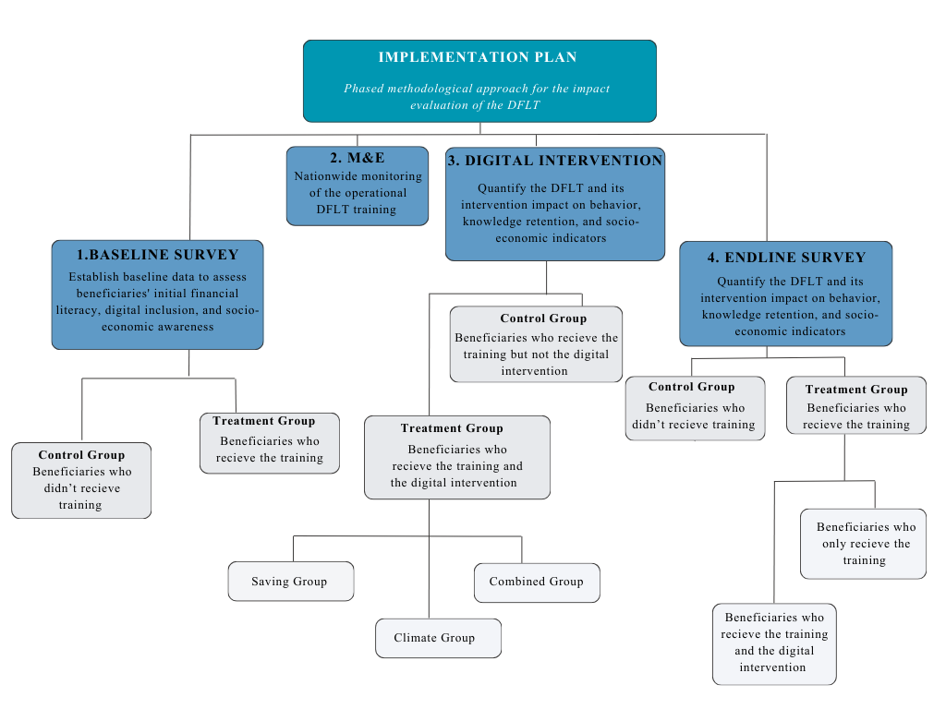
As a part of impact evaluation, the study conducted nationwide field survey, in all the four provinces of Pakistan for the baseline assessment of BISP beneficiaries along with observations of their financial inclusion and financial literacy behaviours. The survey exerted a special focus on the ‘Economic Categorization/Profiling’ of beneficiaries in the survey as variation in economic activities leads to differentiated levels of financial literacy, economic empowerment, and financial inclusion.

For the baseline survey, the multistage clustered and probability to proportional size sampling was adopted for sample selection. Secondly, the beneficiaries were selected from a representative district of each province that has a higher concentration of BISP beneficiaries. As third step, the ratio of beneficiaries was adjusted for urban and rural representations.
Sample Population: BISP women beneficiaries in selected districts of Punjab, KP, Sindh, Baluchistan.
Overall Sample Size (N): The total of 5, 370 BISP beneficiary women were surveyed from 08 districts (province wise) that laid the ground for meaningful analysis for across and within region comparisons. The additional sample beyond the required 5000 provides buffer against attrition and ensures reliability.
This baseline assessment sets the foundation for comparing post-training outcomes and quantifying the program's effectiveness. It provided the detailed outlook of the beneficiaries initial standing across the key indicators such as; foundational and financial literacy, program awareness, employment, income, gender equality, birth registration, and environmental awareness before participating in DFLT.

Monitoring And Evaluation (M&E)
As a part of impact evaluation, a thorough Monitoring and Evaluation (M&E) of the trainings was conducted to assess the quality, relevance and alignment of the training content, materials and facilitation. The primary objective of this phase was to systematically monitor the implementation of the training program across designated geographical areas. This phase was undertaken by establishing detailed framework of M&E process for the entire Digital and Financial Literacy Training Program. This involved establishing and following specific protocols to ensure consistent and accurate data collection regarding the training sessions as they were conducted.
Extensive number of trainings were monitored while these trainings were being conducted across 04 provinces, ensuring equitable representation of urban and rural respondents. The outcomes of M&E helped in identifying the benchmark structures, design, suitable models of training and the sustainability of training interventions. Further, this phase also facilitated the quick overview regarding the areas for improvement and catalyzing the evidence basked action to further enhance the training quality, impact and reach.

Digital Intervention
The digital intervention or video intervention was introduced to overcome the limitations of the traditional 2-day classroom model for imparting the digital and financial literacy training. This intervention was designed as an additional component to physical training, enhancing the learning spectrum of the beneficiaries by providing them with a flexible way to revise, re-learn, absorb and retain the important concepts at their own pace and convenience.
As a part of the intervention, set of short animated educational videos were sent to the beneficiaries, employing WhatsApp as the main distribution channel over course of six weeks. The videos adopt an interactive story telling approach to educate the beneficiaries on the range of topics including; savings, investments, budgeting, financial literacy, fraud prevention, ATM usage, use of calculator, gender equality, and climate change. These videos have been prepared by professional scriptwriters and video animators to ensure the quality and contextual relevancy. Also, this intervention provided the cost effective and convenient solution as compared to standard digital and financial literacy training, employing the use of digital media. In this way, the intervention ensured increased effectiveness of the training, while guaranteeing easier accessibility as well as engagement.

Categorization of Treatment Group
In order to leverage additional digital intervention or video intervention, the treatment arm of the intervention was further categorized into three groups i-e Saving and Financial Inclusion group, Climate group and Combined group. The beneficiary from:
- Saving and Financial Inclusion Group received videos covering topics such as; Saving, Budgeting, Financial Inclusion, Investment, and Fraud Management.
- Climate Group received videos covering topics such as Climate Change, Disaster Risk Reduction (DRR), and Gender Equality.
- Combined Group received the video covering the topics of both saving and climate
group.
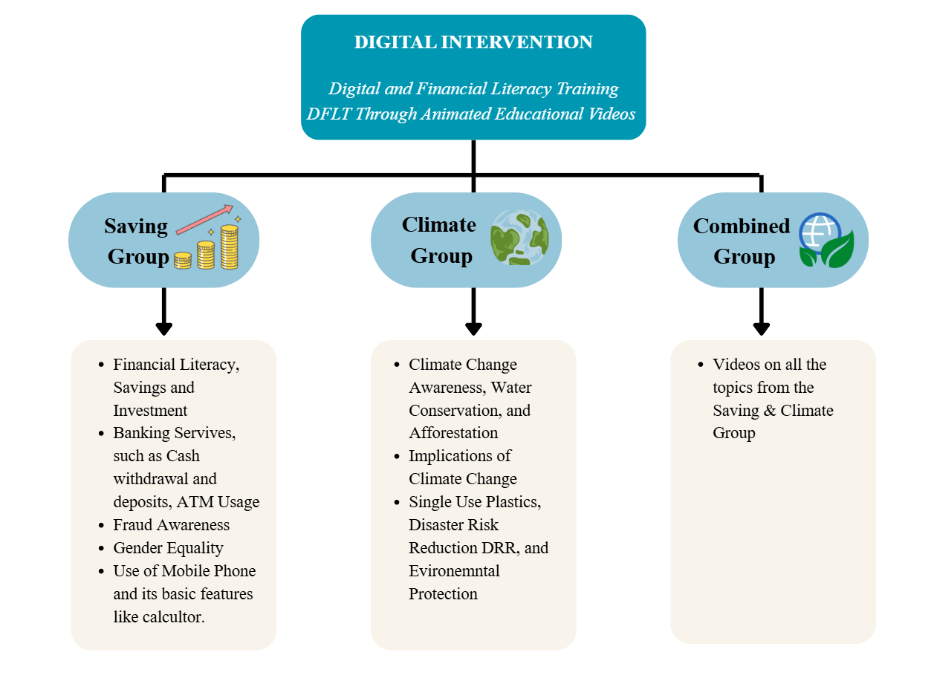
Fig 3:
Automated Video Delivery Process
For the delivery process, an automated python program was developed to ensure the distribution process was more accurate, consistent, and streamlined, doing away with possible human errors like delivering the wrong videos or skipping receivers.
- Each beneficiary received the appropriate videos, which were distributed to their respective groups (Climate, Savings, or Combined).
- The risk of wrong delivery or missing recipients was critically reduced.
- The distribution process was quicker and more streamlined, allowing seamless management in 16 Tehsils with a significant number of beneficiaries.
Afterwards, a robust follow up process was established, where SDPI coordinators reached out to the sample beneficiaries to confirm they had received the videos and resolve the issues faced in receiving the content.
Sample Population: BISP women beneficiaries in selected districts of Punjab, KP, Sindh, Baluchistan.
Overall Sample Size (N) = 1748 women beneficiary
Sample frame: The intervention was implemented in 16 tehsils with 100 to 120 beneficiaries selected for intervention from each tehsil. The primary criterion for the selection of beneficiary in this phase was their access and ownership of WhatsApp which was inquired earlier during the Baseline Survey. The set of 12 videos encompassing the range of topics under the study thematic scope were sent to total of 1748 beneficiaries in 16 tehsils across 4 provinces of Pakistan. To have a balanced assessment, one-third of the beneficiaries were above 45 years, and the rest were below 45 years of age. Then both the younger (less than 45) and older (more than 45) age groups were split into three sub-groups: Climate group; Saving group; and Combined group, guaranteeing an organized assessment among age groups.

Distribution Schedule of Videos
Table 3: The table below shows the detailed and structured weekly distribution schedule for the intervention.
Week | Climate Group | Savings Group | Combined Group
Week 1 | Climate Change - Water Conservation and Afforestation | Financial Literacy | Both Videos
Week 2 | Rural Climate Awareness | Fraud Management | Both Videos
Week 3 | Gender Equality | Savings & Investments | Both Videos
Week 4 | Climate Change – Single-Use Plastics | Banking Literacy | Both Videos
Week 5 | Climate Crisis and Health Risks | Understanding ATM use | Both Videos
Week 6 | Disaster Risk Management | Basic Phone and Calculator use | Both Videos

Endline Assessment
After completion of the Digital and Financial Literacy Trainings and all the designed interventions, the nationwide survey was conducted for the Endline assessment. This is the final component of Impact Evaluation that quantified the program's effectiveness by comparing post-training outcomes against the initial status quo captured during the baseline.
This survey assessed the same indicators that were assessed during the baseline assessment, to facilitate the comparison and determine the changes in beneficiary knowledge, attitude and practices post intervention.
Sample Population: BISP women beneficiaries in selected districts of Punjab, KP, Sindh, Baluchistan.
Overall Sample Size (N): The total of 4,827 BISP beneficiary women were surveyed from 08 districts (province wise) that laid the ground for meaningful analysis for across and within region comparisons. Initially, the endline survey was designed to match the same sample size as the baseline; however, attrition due to factors such as beneficiary death, illness, migration, competing commitments, lack of willingness, and non-response reduced the final sample size of the endline to 4,827. Though the endline sample fell slightly short of the baseline survey, it provided sufficient ground for analysis as the saturation point had been reached.
The endline assessment analysed the impact of DFLT and its interventions on household behaviour, including patterns related to saving, spending, and investment. It helped quantify the knowledge retention levels among trained beneficiaries over time, examine improvements in household-level economic indicators following training, evaluate the use of financial products (digital wallets and ATMs) attributable to the training and any observable shifts in the status of women account holders within their families and communities.

Conceptual Framework
The illustration provides the pictorial representation of the study’s flow, mapping the channels through which the impact of DFLT and its interventions is delivered. The conceptual framework visualizes how the impact is expected to unfold and captured at various stages.
Fig 4:
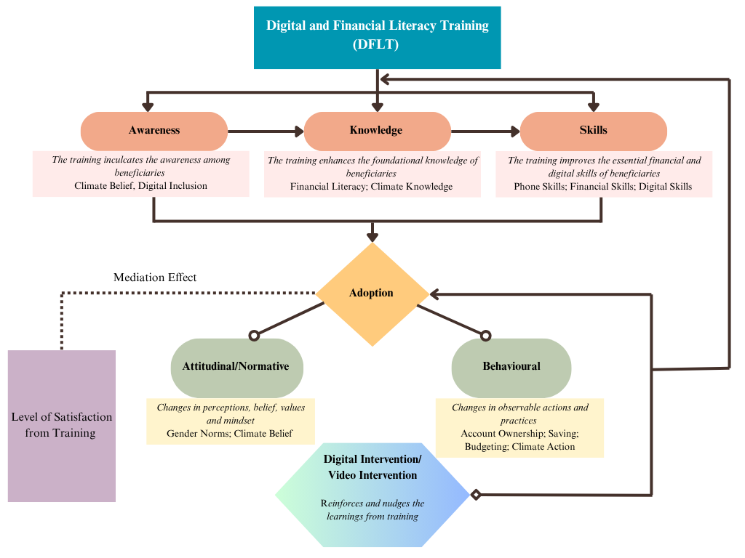

Qualitative And Quantitative Analysis
Qualitative Analysis
The qualitative analysis captured the beneficiary experiences, perceptions, and contextual realities that cannot be fully captured through quantitative measures alone. It explored challenges, opportunities, and behavioural dynamics, providing nuanced insights into knowledge, attitudes, practices, and decision-making processes of the respondents. This approach ensured that the findings are not only descriptive but also reflective of lived realities, thereby strengthening the overall impact evaluation.
Key Informant Interview (KII) of Trainers
Recognizing the pivotal role of trainers in the context of promoting financial literacy, we conducted their key-informant interviews (KIIs) to gather essential insights. The information gleaned from these trainers played a crucial role in shaping targeted interventions aimed at fostering financial literacy.
The KII explored the operational challenges encountered in delivering the trainings, potential improvements in its design and delivery, the most optimal approaches for conducting the sessions, possible areas of collaboration for the betterment of beneficiaries (livelihoods, education and health), their capacity to facilitate the beneficiaries in accessing/opening the mobile money accounts, trainers observation about beneficiaries’ Knowledge, Attitude and Practices (KAP) regarding the training content and their decision making abilities.
Focus Group Discussions (FGD)
To facilitate the qualitative analysis, we conducted the Focus Group Discussions (FGDs) among participating respondents and key influencers, particularly community leaders. A list of stakeholders from the community were determined based on desk review. We propose the following set of FGDs: Three types of focus group discussions were conducted
1)- with beneficiaries who received training,
2)- with beneficiaries who did not receive any training, and
3)- with a group of community leaders.
FGDs with beneficiaries undergoing training aimed to assess the program's effectiveness, exploring their experiences, comprehension of digital tools, and any observed behaviour changes. For beneficiaries not receiving training, FGDs aimed to understand the existing knowledge gaps, barriers, and potential impacts of not participating. Lastly, engaging community members in FGDs provided valuable and contextual insights, gauging the program's broader impact on the community. By triangulating these perspectives, the FGDs aimed to offer a comprehensive understanding of the program's outcomes, strengths, and areas for improvement, informing evidence-based decisions for program enhancement and expansion.
Distribution of FGD by Participants Type: One FGD was conducted with notables of the community and the men of the Household whose women attended the DFLT training in each province. Then the FGDs were undertaken with Treatment and Control groups, with balanced representation across urban and rural Union Councils. Therefore, the findings from these FGDs were synthesized and evaluated to ensure analytical rigor.
Quantitative Analysis
The Quantitative analysis involved collecting data from the selected beneficiaries during the Baseline and Endline surveys and running the statistical techniques to make an impact assessment. The data obtained from the survey had been used as covariates and leading indicators for the ‘Impact Evaluation’. Finally, the synthesis of the findings and the evidence were aggregated and presented via Descriptive Analysis and Empirical Analysis.
- Descriptive Analysis
It described quantitative data through summarizing, organizing and graphical illustrations. Under descriptive stats, the various characteristics of the data were explored such as; Frequency distribution, Range, Interquartile range, Kurtosis. The study used the Exploratory Data Analysis for the purpose of descriptive insights;
- Exploratory Data Analysis (EDA)- EDA attempted to examine and display observed data in relatively straightforward ways which did not require the imposition of a prior model or hypothesis. Essentially EDA analyzed data sets to summarize their main characteristics through data visualization. Data Visualization presented data visually to showcase and communicate the research findings. Data visualization further encompassed the following graphs: Bar charts, Histograms, Scatter plots, Pie charts.
- Empirical Analysis
The empirical analysis used the data to explore the relationships between the key variables, employing the quantitative methods and helping in generating the evidence driven insights. The Randomized Control Trail (RCT) and Difference-in-Difference (DID) is employed as the analytical technique for the Impact Evaluation of different interventions under the Digital and Financial Literacy Training on BISP beneficiaries in Pakistan.
- Randomized Control Trial (RCT)- RCT is widely recognized as the Gold standard of evidence due to its innate ability to establish causal relationships between interventions and outcomes. By randomly assigning eligible participants to treatment and control groups, the RCT ensures that any observed differences in outcomes can be confidently attributed to the financial literacy intervention. This randomization of selection ensures that both the groups (control and treatment) are on an average statistically similar, in all observable and unobservable characteristics prior to the intervention. The RCT technique not only provided insights into the impact of the designed intervention on the digital and financial knowledge of the treatment group but also produced robust results on the impact of different interventions on the financial behaviour and practices. In this way, the rigorous approach provided robust evidence for informed decision-making and policy formulation.
- RCT-Difference-in-Difference- RCT-DiD builds on DiD approach within randomized setting to estimate the causal effect of the intervention over time. To construct a counterfactual, it utilizes the baseline and endline data to compare how the outcome changes for the treatment relative to the control group. In this study, it typically estimates the effect of DFLT and its subsequent interventions by comparing the changes over time between the treatment and the control group.
The data acquired from baseline and endline survey have been utilized for measuring the impact of digital intervention on the digital and financial literacy levels and behaviours of the beneficiaries.
The following specification is used for estimating the impact of DFLT and its interventions, assessed across the four treatment arms
$Y_{it1}=α + β_{1}T_{1i}+ β_{2}T_{2i}+β_{3}T_{3i} + β_{4}T_{4i} +δY_{it0}+ γX_{i} +ε_{i}$ (1)
In the above equation (1),
$Y_{it1}$ is the outcome variable for the beneficiary i at the time t₁ i-e endline.
$T_{1i},T_{2i},T_{3i},T_{4i}$ are the dummy variables indicating the assignment of the beneficiary i to the any four of the treatment arms (mentioned above), with the control groups treated as the omitted category.
$β_{1},β_{2},β_{3},β_{4}$ are the coefficients that capture the average treatment effect of each intervention or treatment arm relative to the control group.
$Y_{it0}$ is the vector of outcomes variables for the beneficiary i at the time t₀ i-e baseline. This specification allows for controlling the pre-intervention levels of the outcome variables.
$X_{i}$ is the vector of control variables such as age, education, marital status and others included to improve precision.
$ε_{i}$is the error term accounting for unobserved factors.
This equation aimed to assess the impact of the intervention while controlling for baseline levels of financial literacy and financial behaviour, allowing for a comprehensive evaluation of the proposed intervention's effectiveness.
Similarly, the RCT-DiD specification is as follows,
$Y_{it}=α + β_{1}{(Treatment}_{i}{ * Time}_{t})+δ{Treatment}_{i }+ { φ Time}_{i}+ γX_{i} +ε_{it}$ (2)
In the above equation (2),
$Y_{it}$is the outcome variable for the beneficiary i at the time t.
${(Treatment}_{i}{ * Time}_{t}$) is the RCT-DiD estimate that captures the average treatment effect over time.
${Treatment}_{i }$is the dummy variable for the assignment of beneficiary to the treatment group.
${ Time}_{i}$ is the dummy variable for time of survey i-e baseline and endline.
$X_{i}$is the vector of control variables.
$ε_{it}$ account for the error term.

Designing Survey Instruments
Separate instruments were designed for structured survey, focus group discussions and in-depth interviews. The structure and choice of sections/questions were guided by desk review/existing financial literacy models review and consultations with BISP. The Computer Assisted Personal Interviewing (CAPI) approach had been used for data collection. All the instruments were initially piloted/tested before implementation. Once finalized, all the instruments were translated to the local languages of selected districts.

Definition And Description of the Key Outcome Variables
The key outcome variables are constructed as standardized and aggregated indexes from the responses collected during the baseline and endline survey. This ensures comparability across participants and provides robust basis for measuring the program impact. The given table provides the definition and description of the key outcome variables and what they measure.
Table 4:
Key Outcome Variables | Description
Level of Satisfaction from Training | It measures the overall satisfaction of the participants from the 2-day Digital and Financial Literacy Training (DFLT), in terms of content, delivery and relevance. It assesses how useful and engaging beneficiaries perceived the DFLT program and its interventions.
Financial Literacy Index | It measures the level of understanding of the basic financial concepts taught during the training such as; saving, investment, and financial products. It reflects the knowledge necessary for informed financial decision making and financial inclusion.
Financial Skill Index | The index assesses the practical ability of managing finances, including handling money, planning expenses and using financial products. This measures the application of financial knowledge in every day life.
Phone Skills Index | This measures the ability to use mobile phone either smart phone or feature phone for functional purposes, including communication and assessing digital services. In this way, it assesses the level of digital literacy which is central to digital and financial inclusion.
Phone Ownership Index | The index captures whether the individual owns or has access to a mobile phone to understand the level of digital inclusion and access.
Account Ownership Index | The index captures whether the individual own and maintain formal financial account such as; bank account or mobile money account, to help assess the level of financial inclusion and access to formal financial services.
Banking Challenges Index | It measures the level of hindrances in assessing and using the banking services, which could be institutional, structural and infrastructural.
Banking Confidence Index | The index measures the level of trust and confidence the individual holds in using the banking services, including the willingness to engage with formal financial institutions.
Saving Index | The index measures level of understanding and how well the saving concepts are inculcated. It also assesses the saving behaviour including frequency and consistency of setting money aside, which reflects the financial discipline and forward-looking behaviour.
Amount of Saving | This shows the scale of financial accumulation by measuring the actual monetary value of money saved by an individual.
Gender Equality Index | The index measures the level of women participation in financial and household decision making, depicting the change intra-household dynamics and women economic empowerment.
Climate Belief Index | The index determines the perceptions and beliefs regarding climate change and its importance. It indicates the awareness and attitudinal orientation towards environmental issues.
Climate Knowledge Index | It measures the level of understanding of the climate related concepts including its risks, impact and mitigation strategies. The index assesses the improvement in knowledge and awareness about climate change pre and post training.
Climate Impact Index | The index measures the extent to which individuals adopt the behaviours that respond to climate risk i-e DRR, implying the translation of acquired knowledge into necessary climate action.
Budgeting Index | It measures the level of understanding and practical adoption of the important financial concept of budgeting. In this way, it assesses the practice of planning and managing income and expenses systematically, demonstrating financial planning behaviour and resource allocation skills.

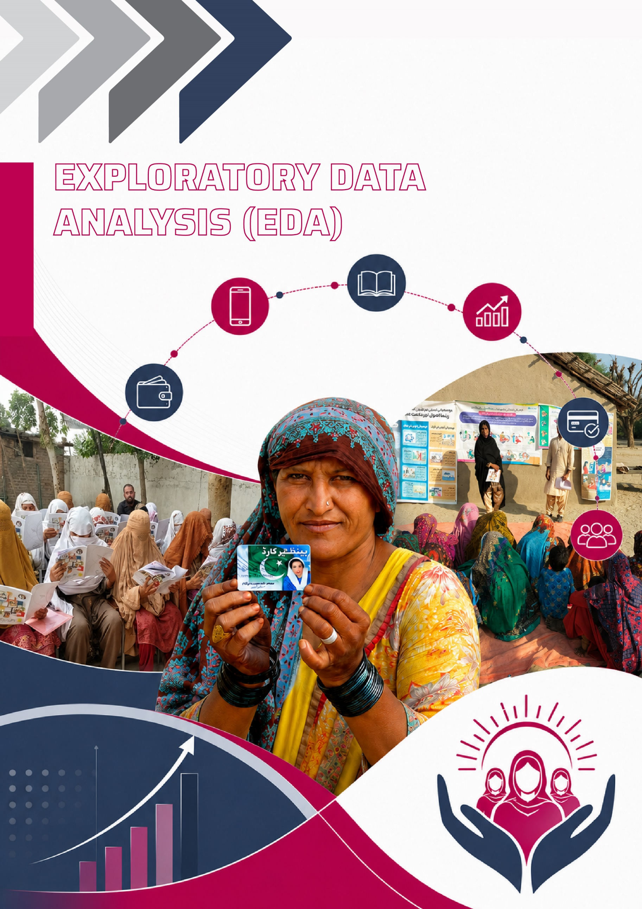

EXPLORATORY DATA ANALYSIS (EDA)

This chapter presents the descriptive analysis and preliminary findings of the study. Section 01 begins by outlining the level of general and basic literacy of the BISP beneficiaries targeted in this study, followed by an overview of their digital inclusion and literacy as well as the financial inclusion and literacy in Section 02 and Section 03. Then Section 04 and 05 examines financial behaviours related to budgeting and saving, while Section 06 focuses on sensitization and understanding on the intricacies of climate change. Section 07 and 08 address level of awareness and adoption around the essential cross-cutting themes of birth registration and gender equality. Finally, the chapter concludes by synthesizing and collating the main insights derived from the descriptive analysis, highlighting the key patterns and implications, further guiding the empirical analysis and impact evaluation.

Basic Literacy
Fig: 5 Do you know how to do basic calculations?
The Digital and Financial Literacy Training (DFLT) program effectively strengthened basic numeracy skills. The proportion of respondents who reported knowing how to do basic calculations increased from 64.3% at baseline to 71.6% at endline. This 7.3-point improvement can be attributed to DFLT’s practical exercises involving simple arithmetic, transaction verification, and balance calculations. These activities were made part of the curriculum to enhance beneficiaries’ confidence in managing routine financial tasks.
Fig 6: How confident are you with performing financial calculations (e.g., change from transactions)?
Confidence in performing financial calculations showed a modest improvement after the training. The share of respondents who felt very confident increased slightly (1.2%), while those who were confident rose 3.7%. This increase, although minor, suggests that the training strengthened participants’ comfort and boosted their confidence with routine financial tasks.
This outcome is also reflected in the participants' ability to correctly answer both basic arithmetic and practical numeracy questions.
- The proportion of respondents giving the correct answer to the subtraction problem (50-26) increased from 46.7% to 51.2%, an improvement of 4.5 percentage points.
- Greater impact was observed in the applied scenario where the rate of the correct answer rose sharply from 71.0% to 77.5%, reflecting a 6.5 percentage point improvement.
Fig 7: What is 50-26?
Fig 8: Suppose you have PKR 100 and you want potatoes. If potatoes are PKR 20 per kg, how many kilos can you buy?

Digital Literacy and Inclusion
Cell Phone
Fig 9: Cell phone Ownership
Fig 10: If no, what is the reason of not having Cell phone
In the category of Digital Inclusion, the descriptive analysis reveals a positive trend in both cell phone ownership and access. The proportion of respondents who reported owning a cell phone increased from 41.9% at baseline to 46.2% at endline representing a 4.3 percentage point improvement in personal ownership.
Cell phone access, which typically includes shared household devices, showed a greater increase with a 9.9 percentage point gain in access. This large increase in access can be attributed to increased awareness and perceived utility fostered by the training.
In addition to this, the DFLT program also succeeded in dismantling the informational barrier and attitudinal barrier ("I do not know how to get one" and "I do not need a cell phone"). The proportion of respondent who exhibited the attitudinal barrier of “I do not need a cell phone” declined from 10.2% in baseline to 9.4% in endline. Similarly, the percentage of respondents with informational barriers showed improvement from 1.2% in baseline to 1% in endline. Although the improvement is modest, it demonstrates the impact of DFLT on the improving knowledge and the subsequent attitude among the participants.

Fig 11: Cell Phone Accessibility
Further, the findings reveal that DFLT was successful in improving the beneficiaries’ confidence and perceived skills in cell phone usage. The proportion of respondents who found the device Easy or Extremely Easy to use increased by 6.6 percentage points and those who found it Extremely Difficult to use decreased by the same percentage points between the baseline and endline surveys.
Fig 12: If yes, how easy/difficult is it for you to use a cell phone?
Fig 13: Do you know how to use the calculator on your feature phone?
The data demonstrates a clear and substantial improvement in the knowledge and ability to use calculator on feature phones. The proportion of respondents who know how to use the feature phone calculator increased from 13.0% to 19.0%. This increase in the ability to use the feature phone calculator has enhanced participants' capacity for independent financial management and accuracy checks.
Fig 14: Do you have a mobile money account?

In terms of financial inclusion, DFLT intervention has demonstrated a direct and positive impact on mobile money account ownership. The proportion of respondents who reported having a mobile money account increased from 12.6% at baseline to 14.7% at endline. This increase, even though small, is a key indicator that the DFLT training translated, improved digital and financial literacy into actual financial behaviour and formal inclusion.
While overall transaction experience remained the same, as no difference was observed in sending and receiving money through mobile money accounts, the intervention significantly boosted user autonomy. The proportion of transactions performed independently rose by 7.2%. This indicates the DFLT incorporating the necessary skills and confidence for independent digital financial participation.

Fig 15: Have you ever sent or received money through a mobile money account?
Fig 16: If yes, did you send/receive the money yourself or ask for help?
The training also effectively influenced behavioural changes in money transfer methods. The data shows that participants moved significantly away from relying on informal methods and asking for help. Instead, the adoption of more accessible formal channels like POS agents and Mobile Money increased. This shift is the most compelling evidence that the training successfully promoted the practical adoption of digital and formal financial mechanisms.

Fig 17: If need to, how do you transfer money?

Financial Literacy and Inclusion
- Banking
Fig 18: Do you know how to open a bank account?
Fig 19: Do you own/have any bank account
Fig 20: Do you know how to use ATM machine?
Fig 21: How easy/difficult is it for you to use bank account?
In the category of Banking awareness and usage, the training successfully enhanced participant’s knowledge of how to open a bank account, subsequently contributing to an increase in actual account ownership. The proportion of respondents who knew how to open a bank account increased 13.8 percentage points and bank account ownership increased by 14.8% percentage points between baseline and endline surveys. These improvements indicate that the DFLT effectively enhanced participants’ understanding of basic account-opening procedures by making it a part of the curriculum.
The data also validates these results with a 15-percentage-point decline in the proportion of participants who previously found bank account usage “very difficult.” The participants' knowledge of how to use an ATM machine also increased significantly from the baseline to the end-line surveys. The proportion of respondents who know how to use ATM machines increased by 12.8 percent.
Fig 22: Can you identify different denominations of currency?

Identification of Currency Notes: When inquired about the identification of different denomination of the PKR Currency Notes, the 93.6% of the beneficiaries’ women responded with ‘Yes'. While, this percentage increased to 94.5% during the endline, depicting that some of the women who previously lacked the ability to identify the currency notes were able to do so post training.
Fig 23: Are you aware of the various financial products available, such as loans, insurance, and microfinance?
The DFLT intervention also increased the financial product awareness among the participants to some extent. The most effective outcome was the movement of respondents from having no knowledge to some knowledge, resulting in a net gain of 2.9 percentage points. The increase in the 'Somewhat' category suggests that the training provided foundational information, even if it did not immediately lead to comprehensive ('Yes') awareness.
The decline in the ‘Yes’ category is logically because of a common phenomenon in education where a person overestimates their own competence due to lack of knowledge in a specific area. At baseline, some respondents may have over-reported their knowledge (claiming 'Yes'). But when they learned about those financial products and gained an accurate understanding after the training, they might have downgraded their self-assessment from "Yes" to "Somewhat". Therefore, there is a decrease in the ‘Yes’ responses and a 5.9% increase in 'Somewhat' awareness, indicating learning and better calibration.
- Investment
Fig 24: Are you aware of investment opportunities (e.g., government bonds, micro-investment schemes)?
Fig 25: What is called investment
The training intervention has successfully fostered an investment and savings-oriented mindset in its participants. Awareness of investment opportunities increased modestly, rising from 17.1% at baseline to 20.0% at endline. The proportion of participants who correctly identified investment as a productive asset (Opening Grocery Shop at Mohala) increased from 56.4% at baseline to 61.3% at endline. Since the concept of investment is complex relative to other financial topics, even a slight improvement suggests growing exposure and familiarity among participants.
Supporting this outcome, the analysis reveals a clear and combined shift in behaviour toward future-oriented activities. The total number of respondents who reported saving or investing their extra income increased by 5.4 percentage points (from 27.6% to 33%). The proportion of respondents who reported having their money invested increased 5% between baseline and end-line surveys indicating the training may have encouraged some beneficiaries to consider low-risk or small-scale investment options.
Fig 26: Have you ever invested your money?
Fig 27: What do you typically do when you have extra income?
- Fraudulent Behaviour
Fig 28: If you receive a call from someone who says they are calling from a particular bank/Easypaisa/BISP and asks the pin code of your ATM then what would you do?

Fig 29: If a POS agent asks for extra charges or fee for the transaction, what would you do?
The DFLT intervention was highly effective in building participant’s digital security and fraud awareness. When asked about a hypothetical situation in which they were asked their ATM pin on the call, the safest response, "End the call immediately and contact the bank or BISP directly using a phone number you know is legitimate," saw the most significant growth, rising from 36.3% at baseline to 55.6% at endline. Consequently, the proportion of participants who would "Provide the PIN without hesitation" dropped (from 7.3% to 5.4%), and those who would try to verify the caller but still engage ("Provide the PIN but ask for additional information...") also decreased from 9.4% to 7.7%.
In another common risk scenario involving unauthorized charges, the most secure and appropriate action, "I would refuse to pay the extra charges and report the agent to the relevant helpline," saw a massive increase of 18.2 percentage point gain.
In both scenarios, the training induced a large-scale shift toward the safest, most formal, and proactive behavioural response, demonstrating that the program successfully provided the knowledge needed to protect personal financial assets from exploitation and fraud.
- Interest Rate
Fig 30: How familiar are you with the concept of interest rates (e.g., on loans or savings)?
The DFLT intervention improved understanding of a complex financial concept. The 4.8 percentage point decrease in absolute unfamiliarity in baseline was directly mirrored by a 4.8 percentage point increase in the combined 'Somewhat' and 'Very familiar' categories in endline. This demonstrates effective learning and knowledge transfer regarding interest rates, a concept fundamental to utilizing both loans and savings products.
The data indicates that the DFLT intervention moved a segment of the population from having no familiarity to having at least some level of awareness, particularly boosting confidence in understanding the concept.
- Budgeting
Fig 31: Have you ever created a budget to manage your household expenses?
Fig 32: How do you usually plan your monthly expenses (e.g., food, bills, savings)?
The training instilled structured financial planning habits among its participants by shifting their behaviour to proactive budgeting. The graph shows a significant increase in the "Yes, always" category, which grew from 15.2% to 19.9%. This behavioural change is corroborated by the shift in monthly planning methods with 6.3 percentage points increase (from 24.5% to 30.8%) in respondents who "plan carefully with a budget".

Financial Behaviour- Savings
Fig 33: Do you understand the importance of saving money?
In the category of Savings, the DFLT intervention bridged the "knowledge-action gap" by translating conceptual saving awareness into concrete saving habits. While the participants’ perception about the importance of saving was already saturated at baseline (94.4%), the training was effective in creating a surge in actual savings participation, which rose from 70.2% to 95.8%.
Fig 34: Do you save money?
Fig 35: Frequency of Saving
In terms of frequency of savings, there is slight improvement in the daily savings from 22.7% in baseline to 23.4% in endline. Similarly, the monthly savings improved from 30% in baseline to 31.2% in endline. The slight gains suggest that DFLT had positive, though incremental influence on the participant’s saving behaviour. This positive change in saving behaviour was underpinned by a significant shift in institutional trust as the reliance on the self-ownership of cash ("only yourself") decreased from 71.1% to 64.5%, while trust in formal banks nearly doubled, increasing from 10.2% to 18.2%.
Fig 36: If you are saving then, whom would you trust your money with?

Furthermore, the training intervention improved retention of saving, evidenced by a 5.6 percentage point decrease in ultra-short-term savings (less than a week) and a corresponding rise in respondents holding savings for a month or longer.
Collectively, these trends demonstrate that the program moved beyond theoretical instruction to establish disciplined habits and foster growing confidence in the formal financial ecosystem.
Fig 37: How long are you able to keep your saving without spending at least half of it?

Climate Change
Fig 38: Have you noticed any changes in weather patterns (e.g., temperature, weather pattern, rainfall) in your area over the past few years?
Fig 39: Do you believe that climate change is affecting your community?
The data regarding climate change awareness and adaptation indicates that the DFLT intervention shifted the community’s perspective from experiential observation to a formalized recognition of environmental risk.
Foundational awareness of shifting weather patterns was already high at baseline (79.6%) and remained stable through the endline (80.5%), confirming that participants were already aware of climate volatility.
The training was effective in bridging these personal observations with a sense of collective urgency, as the belief that climate change is actively affecting the community rose from 78.8% to 82.4%. This increased clarity is further reflected in a reduction of uncertainty regarding the drivers of climate change; the proportion of respondents who were "not sure" about its causes fell from 21.2% to 15.9%, with more individuals attributing the changes to a combination of human and natural factors (19.2%) or specific natural drivers (41.2%).
Fig 40: Do you believe that climate change is primarily caused by

Analytically, a change occurred in the perceived relevance of climate adaptation to the participant's livelihoods. The proportion of respondents who reported ‘no steps taken yet’ declined significantly from 71.4% to 64.1%. This outcome suggests that the training was helpful in moving the audience out of a state of indifference into a state of conscious preparedness like income diversification (9.9%) or new farming practices (2.6%).

Fig 41: What steps, if any, have you taken to adapt to the effects of climate change on your livelihood?

Disaster Risk Reduction (DRR)
The comparison of baseline and endline findings indicate an overall improvement in disaster awareness, preparedness behaviours, and financial resilience among participants following the training. Awareness of disaster types increased from 55.6% to 59.3%, reflecting enhanced risk recognition, an essential first step toward informed preparedness.
Fig 42: Are you aware of any types of disasters?

Behavioural readiness improved notably, as the proportion of respondents identifying safe shelter as a protective action rose sharply from 44.2% to 66.2%, while reliance on unspecified “other” measures declined substantially (from 24.7% to 5.5%). This shift suggests that participants adopted more structured and recommended safety strategies rather than informal coping mechanisms.

Fig 43: How did you protect yourself during the disaster?
Disaster related financial preparedness showed gradual but meaningful progress. Households with dedicated emergency savings increased from 10.1% to 13.9%, and immediate access to financial resources improved from 13.8% to 20.0%, although the majority still lacks liquidity during crises. More notably, the training was particularly effective in creating an understanding about the importance of securing financial documents to prevent potential loss during disasters. The share of respondents with a plan to secure important financial documents rose markedly from 29.1% to 45.3%.
Fig 44: Do you have savings set aside specifically for emergencies or disasters?
Fig 45: In case of a disaster, do you have immediate access to financial resources (e.g., cash, bank savings, credit) for urgent needs?

Fig 46: Do you have a plan to secure important financial documents (e.g., bank records, property titles) during a disaster?
Forward-looking financial planning also strengthened, with participants reporting a financial backup plan increasing from 7.0% to 11.3%, alongside a decline in those without any plan. At the community level, participation in disaster risk management initiatives grew modestly (6.7% to 10.4%), while willingness to engage in future preparedness activities rose significantly from 47.7% to 57.0%. These positive outcomes signal an encouraging shift toward collective resilience.

Fig 47: If you lost your home or livelihood due to a disaster, do you have a financial backup plan (e.g., savings, access to loans)?

Fig 48: Do you participate in any community-led initiatives for disaster risk management (e.g., neighbourhood groups, volunteer organizations)?
Fig 49: Would you be willing to participate in future community initiatives for disaster preparedness (e.g., community drills, awareness programs)?

Birth Registration
Fig 50: Do you think it is important to register the birth of a child?
Fig 51: Do you know why it is important to register the birth of a child?
Digital and Financial Literacy training also focused on strengthening awareness of essential civic documentation. The data highlights notable improvement in participants’ knowledge and preparedness regarding birth registration.
While the participants already recognized its value due to prior programs concerning birth registration, understanding of its benefits improved, with respondents identifying birth registration as a means of securing legal identity and access to services rising from 75.3% to 82.9%. This shift signifies deeper conceptual clarity rather than merely attitudinal agreement.
Fig 52: Do you know the difference between Birth Certificate and B-Form?
Knowledge-related indicators showed stronger progress. Awareness of the difference between a birth certificate and B-Form increased substantially from 28.8% to 38.6%. Similarly, respondents who fully understood the registration process grew from 23.9% to 39.4%, accompanied by a decline in those who did not know the process (49.8% to 38.1%). These changes suggest that the training helped bridge critical information gaps that often hinder timely registration.
Fig 53: Are you aware of the steps required to register a child’s birth in your area?
Confidence in the ability to register a child also strengthened. Participants reporting being confident increased from 39.2% to 43.3%, while those extremely confident rose from 23.6% to 28.4%. At the same time, extreme uncertainty fell from 15.8% to 11.8%.
Fig 54: If need to then how confident are you to register a child’s birth in your area?

Gender Equality
The data regarding gender equality suggests a community in the midst of a transition, where perceptions of social rights are improving more rapidly than traditional household power dynamics.
Perceptions of Social and Economic Equality: At the community level, there is a clear positive trend toward recognizing equal rights for men and women. Sentiment regarding equal access to education saw an increase, rising from 68.4% (Strongly Agree + Agree) at baseline to 73.1% at endline. A similar upward trajectory is visible regarding equal opportunities to work, where it grew from 46.3% to 51.4%. Analytically, this indicates that the intervention has fostered a more inclusive social outlook concerning women's roles in the public sphere and professional life.

Fig 55: Men and women in your community have equal access to education?
Fig 56: Men and women in your community have equal opportunities to work?
Household Financial Decision-Making: Internal household financial dynamics remain more resistant to change as compared to shifts in community-wide perceptions. The percentage of respondents who believe women have equal financial decision-making power grew modestly from 51.8% to 55.5%. However, when asked who actually makes these decisions, the proportion of respondents who reported to have taken the primary financial decision on themselves has been increased from 15% to 17% post training. Moreover, the "Spouse" remains the dominant figure, yet there is a decrease from 76.0% to 73.5% at the endline. This suggests that while participants are beginning to value the concept of financial equality, the practical application of shared financial control within the household is evolving slowly.
Fig 57: Women in your household have equal decision-making power regarding financial matters?
Fig 58: Who primarily makes decisions about financial matters in your household?

Domestic Decision-Making and Agency: The most significant shift in gender dynamics occurred in the domestic and personal spheres. The proportion of respondents who were able to take domestic decisions by themselves rose from 20.3% to 26.7% whereas spouse dominant decision making decreased from 68.5% to 47.1%. A change has been observed in the joint decision making with the spouse that rose to approximately 16% indicating a positive shift in collaborative choices in the household dynamics.
Fig 59: Who primarily makes decisions about domestic matters in your household?
Fig 60: How often do you visit a market to buy groceries and other essentials?
Additionally, personal agency measured by the frequency of visiting the market for essentials, showed a positive change with more participants engaging in these solo trips (“Sometimes”; 50.7% to 59.6%). This reflects a growing level of independence and shared responsibility in the day-to-day management of the household.

Key Takeaways from Exploratory Data Analysis EDA
The Digital and Financial Literacy Training (DFLT) intervention has proven to be effective in transforming participants from passive observers of their financial and digital environments into proactive, informed agents. By bridging the persistent knowledge-action gap, the program moved beyond theoretical awareness to instill disciplined habits, most notably in the areas of structured budgeting and formal savings. This shift indicates a significant change in institutional trust, with participants moving towards formal financial ecosystems over informal methods.
In the digital and banking domains, the intervention empowered individuals to conduct transactions independently and navigate formal banking procedures with greater confidence. Alongside this, participants demonstrated a more cautious and informed approach to digital security, shifting away from vulnerable practices toward actively protecting themselves against fraud and financial exploitation.
The program also strengthened the community’s understanding of broader risks, such as climate change and natural disasters. Instead of relying mainly on informal or reactive coping strategies, participants are in favor of adopting planned safety measures and showing awareness of the need for long-term adaptation. Together, these changes point to an improvement in household adaptive capacity and a growing recognition of how environmental challenges can directly affect livelihoods.
Finally, the intervention contributed to positive social and civic changes within the community. Although changes in household financial roles tend to develop more slowly than shifts in broader social attitudes, there are early signs of more shared decision-making within households and greater individual confidence among participants. Alongside this, increased awareness of the importance of legal documentation, such as birth registration, reflects a growing engagement with formal systems. Together, these changes suggest that the DFLT program has helped build essential skills and confidence that support a gradual move toward a more secure, inclusive, and empowered community.

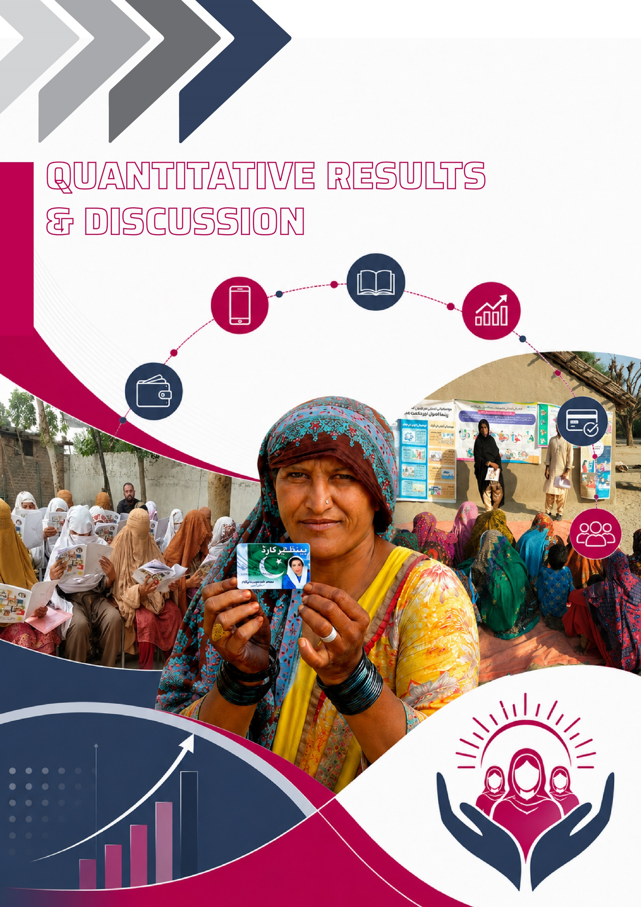

QUANTITATIVE RESULTS & DISCUSSION
The chapter presents the quantitative results for the study, which are aligned closely with the stated objectives of assessing the impact of Digital and Financial Literacy Training, DFLT on the BISP beneficiaries in Pakistan. The analysis systematically evaluates how the 2-day training has influenced the knowledge, awareness and practical adoption across the range of topics purposefully designed and integrated within the training curriculum. To situate empirical evidence, it employs the rigorous impact evaluation technique of RCT and RCT-DiD, to systematically assess the program outcomes. The findings are framed around the range of key outcome variables from knowledge retention to behavioural impact and broader indicators of economic well-being and women empowerment among the targeted BISP beneficiary women. Additionally, it explores the differential impacts of the training across regions and demographic groups that help identify the patterns of effectiveness of training and potential segmentation of beneficiaries for dedicated interventions. Taken together, it aims to deliver whether the training objectives have been achieved, highlight the areas of strong impact, identify lags that inform the training modules and guide improvement for future scale-up.

Measuring The Impact of Digital and Financial Literacy Training (DFLT) Program on Benazir Income Support Programme (BISP) Beneficiaries, Using Randomized Control Trial (RCT)- Difference in Difference (RCT-DiD) Technique
The Randomized Control Trial (RCT) and the Difference in Difference (DiD) technique is employed to investigate the impact of DFLT on the BISP beneficiaries in Pakistan. The Baseline assessment collected data from 5,370 beneficiaries, while the Endline assessment collected data from 4,827 beneficiaries making a combined dataset of 10,197 observations. However, when the CNICs were matched for the quantitative analysis, 593 observations were dropped as they did not match, leaving a final dataset comprising of 9,604 observations. Now the final dataset represents 4,802 individuals each surveyed twice, once at baseline and then at endline, post training and interventions. The CNIC number of these individuals serves as the panel variable ensuring that individuals are consistently tracked across both the survey rounds. Furthermore, the standard errors are clustered at individual level to account for within person correlation. For the RCT estimation, the randomized assignment ensures that the Treatment and Control group are statistically comparable, thereby isolating the casual impact of training by controlling for both observed and unobserved confounding factors. Finally, to facilitate the RCT Difference-in-Difference estimation, the fixed effect model is employed, which controls for all the time in-variant characteristics and identifies the within person changes over time.

Impact of DFLT- Results Across Treatment Arms
The coefficient of RCT represents the average treatment effect of the DFLT and its interventions on the list of outcomes variables or indexes mentioned such as financial literacy index, financial skills index and others. In other words, it captures the difference in outcomes between the treatment and control group, while holding the allocation of participants to either group as random.
Table 5: Impact of Digital and Financial Literacy Training (DFLT): Results Across Treatment Arms
Index/Variables | T 1  Training  (HBF+PDS) | T 2  Training + Climate Video | T 3  Training + Saving Financial Inclusion Video | T 4  T₁ +T₂ + T₃  Combined
 | Coef.  (S.E) | Coef.  (S.E) | Coef.  (S.E) | Coef.  (S.E)
Level of Satisfaction from Training | 0.119***  (0.027) | 0.185***  (0.053) | 0.125***  (0.038) | 0.329***  (0.074)
Financial Literacy Index | 0.097***  (0.012) | 0.165***  (0.031) | 0.072***  (0.020) | 0.080*  (0.041)
Financial Skills Index | 0.379***  (0.020) | 0.309***  (0.034) | 0.232***  (0.027) | 0.231***  (0.045)
Phone Skills Index | 0.128***  (0.020) | -0.099  (0.070) | 0.075**  (0.031) | 0.005  (0.056)
Account Ownership Index | 0.168***  (0.016) | 0.324***  (0.026) | 0.147***  (0.024) | 0.313***  (0.032)
Saving Index | 0.012***  (0.003) | -0.006  (0.004) | 0.011**  (0.005) | 0.006  (0.006)
Amount of Savings | -191.66  (338.87) | 4165.13*  (2211.46) | 528.30  (822.79) | 9203.06**  (3576.85)
Gender Equality Index | 0.000  (0.007) | -0.008  (0.012) | 0.011*  (0.007) | 0.010  (0.012)
Climate Belief Index | 0.050***  (0.019) | 0.110***  (0.033) | -0.030  (0.021) | 0.113***  (0.036)
Climate Knowledge Index | 0.129***  (0.014) | 0.075***  (0.019) | 0.031  (0.027) | 0.050  (0.034)
Climate Impact Index | -0.104  (0.125) | 0.160*  (0.088) | -0.108  (0.131) | 0.087  (0.142)
Budgeting Index | 0.190***  (0.018) | -0.158  (0.130) | 0.163***  (0.023) | -0.127  (0.508)

Level of Satisfaction from the Training-When inquired about the satisfaction from the training, the participants of the treatment group increasingly reported the perceived satisfaction from the training and its interventions. The result shows the positive and significant effects across all the treatment arms with the highest impact in the combined arm T4 (0.329). This shows that the participants regarded the training and its interventions as highly useful, contextually relevant, and engaging, underscoring the effectiveness of the program design.
Financial Literacy Index- The results indicate the positive and significant effect of the DFLT and its interventions on the participant’s financial literacy index, though the magnitude of effect varies. The treatment arm T2 yields the strongest improvement (0.165), suggesting that the beneficiaries who attended the 2-day Digital and Financial Literacy Training DFLT and received videos related to climate, scored on an average 0.165 units higher in the financial literacy index as compared to the reference group (control group). Similarly, the consistent positive pattern is seen in other treatment arms with the combined arm showing the relatively smaller yet still marginally significant effect. Overall, the estimates suggest that the beneficiaries who participated in the 2-day training and underwent digital intervention exhibited the improved understanding of the core financial literacy concepts.
Financial Skills Index- The estimates indicate consistently positive, significant and notable improvement in the financial skills of the treatment beneficiaries across all the four treatment arms. The treatment arm T1 shows the largest gains (0.379), suggesting that the beneficiaries who participated in 2-day DFLT, on average exhibit 0.379 units higher financial skills as compared to the ones in the control group. The result ascertains that the composition of 2-day training i-e; Structured Handbook Format (HBF) combined with Practical Demo Sessions (PDS) proved to be essential in building the financial skills of the participants, highlighting the importance of interactive in person learning session for skill development. At the same time, the impact across other interventions indicates that these approaches complemented the training, reinforcing learning and helping participants sustain it over time. Overall, the findings of RCT impact assessment reveal that the effect of DFLT is not trivial and it points to the meaningful behavioural shift among the trained beneficiaries. As the training not just improved the conceptual understanding of the financial concepts but equipped them with the ability to translate the knowledge into actionable skills and make sound financial decisions.
Phone Skill Index- The results for the phone skills index reflect that the training significantly improved the phone related skills among the those who attended the Digital and Financial Literacy Training, DFLT. The coefficients are positive and significant across the treatment arm T1 and T3, with no statistically significant impact in the T2 and T4. The findings suggest that the training alone has a substantial impact, as the estimate of the treatment group exhibited 12.8 percentage point better knowledge and ability to fully operate the mobile phone (both feature and smartphone) as compared to control group. This observed impact can be attributed to the dedicated module in the DFLT handbook, delivered during the 2-day classroom training. This module emphasized the importance and practical usage of phone and was delivered effectively combined with practical demo session and hands on demonstrations that enabled participants to internalize and practice these skills. Learning was further improved by video intervention; contextual digital learning helped enhanced understanding and promote digital adoption. As a result, treatment beneficiaries exhibited stronger ability to operate feature phone, including essential functions that marks digital and financial inclusion of these marginalized women. These competences encompassed using the calculator, dialing and receiving calls, sending and receiving text messages. The findings suggest that the training and interventions were effective in enhancing the participants mobile phone proficiency, which is a critical prerequisite for the digital and financial inclusion of the marginalized women.
Account Ownership Index- The RCT estimates across all the treatment arms indicate substantially strong, positive and statistically significant impact of the DFLT and its interventions on the account ownership index of the participants. The largest effect is observed in the treatment arm T2 and treatment arm T4 (combined), followed by the other two arms. The RCT estimate shows that on an average, the beneficiaries in treatment arm T2 have 0.324 units higher account ownership index than those in the control group. This improvement is observed because the training strongly emphasized the importance of account ownership as a pathway toward true financial inclusion. During the two-day training, participants were taught how to open a mobile wallet and the bank account, while facilitators also highlighted the importance and benefits of opening a bank account. These concepts were reinforced not only during the in-person training sessions but also through informative animated videos shared via WhatsApp as a component of Digital/Video Intervention. These findings suggest that the DFLT and its intervention effectively addressed both knowledge and access barriers related to financial inclusion. By building awareness and practical understanding, the training encouraged participants to adopt formal financial services, thereby increasing the likelihood of holding a personal account and advancing true financial inclusion among marginalized segments of society.
Saving Index- The impact of Digital and Financial Literacy Training (DFLT) and its interventions remain relatively modest on the saving index of the beneficiaries. The estimates are positive and significant in the treatment arm T1 and the treatment arm T3, while the other two treatment arms have no significant effect. The RCT estimate (0.12*) for the saving index suggests that individuals who attended the 2-day training and received set of saving videos (as a part of digital intervention) scored on an average 0.12 units better on the saving index as compared to the control group. This implied that treatment beneficiaries who received both 2-day training as well as the digital/video intervention (Saving Group) demonstrated improved attitudes towards saving and the overall saving practices relative to the control group (who didn’t participate in the training, nor received any intervention). This improvement in the saving index is attributed to the dedicated sessions delivered during the 2 day in-person training, complemented by the handbook that underlined the importance of savings for financial security, dealing with emergencies and achieving long term financial goals. Moreover, the digital intervention further reinforced the training content through animated informative videos shared with the treatment beneficiaries over WhatsApp, which enlightened them about the importance of savings in an interactive way and encouraged them to adopt the saving habit. Altogether, the training and its interventions showed to have played a crucial role in strengthening participants saving orientation.
Amount of Savings- The findings for the amount of savings indicate a substantial positive impact of the DFLT on the actual amount of savings held by the participants. The estimate for treatment arm T4 (combined) is large, positive and significant, followed by the treatment arm T2, while no significant effect is observed across the treatment arm T1 and treatment arm T3. The results indicate that beneficiaries in the combined treatment arm (underwent training and all its interventions), reported to save PKR. 9,203 more as compared to the beneficiaries in the control group on average. These findings reflect that the training was not only significant in sensitizing and raising awareness towards savings but also translated these learnings into the tangible outcome of increase in the level of savings accumulated by the participants. The significant increase in savings reflects the effectiveness of the intervention in encouraging participants to adopt essential financial behaviours, such as setting aside money regularly (saving) and recognizing the importance of financial preparedness. By improving financial awareness and reinforcing the volume of saving through both the training and follow-up digital intervention, the impact evaluation validates the impact of DFLT in motivating and encouraging participants to save.
Gender Equality Index- The results show relatively weaker or no meaningful impact of the DFLT on the gender equality index. The positive and statistically significant estimate is observed only across the treatment arm T3 (0.011), which suggest that beneficiaries who attended 2-day DFLT and received Saving/Financial Inclusion videos during digital intervention demonstrated improvement in behavioural and attitudinal change towards gender equality as compared to the beneficiaries in the control group. This behavioural change is the outcome of the explicitly integrating gender equality into the training content with discussions underscoring the importance of women’s equal participation in financial decision-making, access to financial services, and economic empowerment. The significant impact in the treatment arm T3 is particularly meaningful, as the dedicated video shared with the Saving Group beneficiaries deliberately addressed the issue in thoughtful and engaging manner. Through engaging storytelling, it highlights the role of women in household financial management and the broader benefits of gender-inclusive economic participation. The intervention also touched upon education access and its relevance across all aspects of life. The training and intervention alone cannot change the norms and intra household gender in a short span of time, it requires continuous and targeted interventions.
Climate belief Index- The findings show the DFLT and its intervention have positive and significant impact on the climate belief index across treatment arms T1, T2 and T4, with the combined treatment arm T4 showing the strongest effect. The RCT estimate (0.113) suggest that treatment individuals who received DFLT and all its interventions scored relatively higher on the climate belief index as compared to the control group, indicating better awareness and acknowledgement of the intensifying climate challenges. The findings imply that 2-day classroom training supported by PDS and HBF, and the additional set of climate focused videos delivered during the digital intervention were effective in improving awareness levels, dismantling the misconceptions and creating observable differences between groups. Altogether, training and interventions produced positive effects in reinforcing environmental awareness and shaping climate related beliefs.
Climate Knowledge Index- The results from impact evaluation demonstrate a significant improvement in participant’s climate-related knowledge, with the significant estimates across treatment arm T1 and T2. The coefficient for the T1 (0.129) shows substantial gain, implying that the beneficiaries in treatment arm T1 exhibited higher levels of knowledge about climate issues as compared to those in the control group. This improvement in knowledge reflects the structured learning approach used during the training, where topics such as climate change, disaster risk reduction (DRR), and environmental responsibility were explained in accessible terms. The learning process was further reinforced through educational animated videos shared under the Climate Group of digital intervention, helping participants better grasp the causes and consequences of climate-related challenges.
Climate Impact Index- Contrary to climate belief index and climate knowledge index, the impact of DFLT and its interventions on the climate impact index is relatively small, with the estimates of only treatment arm T2 showing marginally positive significant results. The estimate (0.16) suggests that beneficiaries from the treatment arm T2 (2-day Training + Climate Videos) scored on an average 0.16 units higher, indicating a greater inclination towards the environmentally responsible practices than those in the control group. This change suggests that exposure to the interventions may have encouraged participants to become more conscious of their environmental behaviours. Overall, the outcomes stem from the comprehensive coverage of climate topics during the 2- day training, which introduced participants to practical climate actions and environmental responsibility. Detailed discussions on climate change awareness, reducing single use plastics, disaster risk reduction (DRR), and individual and community level climate action were reinforced through videos that emphasized the importance of environmentally responsible practices and encouraged participants to translate knowledge into action. Yet, the relatively weaker significant effect suggest that shifting deeper perceptions and inducing behavioural adaptation requires more specific and repeated exposure.
Budgeting Index- The results show a positive and statistically significant effect of the DFLT and its intervention on participant’s budgeting skills and behaviour. The largest effect is seen in the RCT estimate of the treatment arm T1 (0.19) indicating the beneficiaries who attended 2-day classroom training demonstrates on an average 0.19 units higher budgeting skills than the control group beneficiaries. Similar and consistent results are observed for the treatment arm T3, while the T2 and T4 yield no significant impact. The findings essentially suggest that the physical classroom training (practical demo session and handbook) have proved to be central in delivering the message on importance of budgeting and enhancing the participants’ skills. Furthermore, the digital intervention improved understanding and reinforced the learning, ensured the concepts are absorbed more correctly and sustained over time. Taken together, the training and the interventions have encouraged participants to think more systematically about managing their finances and planning expenditure, and the subsequent change has been observed in the budgeting behaviour of these treatment beneficiaries.

Overall Impact of DFLT: Results Across Key Outcome Variables
To further strengthen the causal inference derived from the RCT, the study utilizes the RCT-DiD framework within the randomized design. The coefficient of RCT-DiD is estimated as the interaction term of treatment beneficiary with the timeline of survey (baseline and endline), which captures the average treatment effect by measuring the differential change in outcome between control and treatment groups over time. This captures the respondents which are part of the treatment group and are surveyed in both baseline and endline assessment, thereby enabling the robust impact evaluation. In this way, the Difference in Difference (DiD) estimate measures the causal effect of Digital Financial Literacy Training (DFLT) and its interventions.
Table 6: Overall Impact of Digital and Financial Literacy Training (DFLT)
Outcomes | Coef. (S.E) |  | Interpretation
Level of Satisfaction from Training | 0.223**  (.113) |  | The beneficiaries showed sustained level of satisfaction from the training.
Financial Literacy Index | 0.106 ***  (.037) |  | The index demonstrates a strong and robust improvement, confirming sustained gains attributable to training.
Financial Skill Index | 0.132 ***  (.029) |  | The financial skills improved significantly, indicating retention and application of learned competencies.
Phone Skills Index | 0.101***  (.027) |  | The training successfully imparted practical digital capabilities.
Account Ownership Index | 0.077***  (.019) |  | The training effectively improved the financial inclusion, indicated by increased account ownership.
Saving Index | 0.008*  (.004) |  | The index depicts a small but statistically significant increase, reflecting a gradual behaviour change.
Climate Belief Index | 0.012  (.035) |  | No significant change in climate belief suggests that beliefs are less responsive in the short term.
Climate Knowledge Index | 0.094**  (.038) |  | The climate knowledge improved moderately, depicting understanding and retention of the information delivered.
Climate Impact Index |  | 0.325  (.248) | No significant change in the subsequent climate action.
Budgeting Index |  | 0.033  (.029) | The budgeting doesn’t appear to improve significantly in the immediate term.

The RCT-DiD estimation offers added robustness to impact evaluation by accounting for the change across time. Overall, the RCT-DiD findings largely corroborate the findings from RCT, reinforcing the direction and consistency of the estimated effects. However, the magnitude of the RCT-DiD is generally smaller and in some cases statistically insignificant. This might be due to the estimation strategy adopted under RCT-DiD technique, which differences out the baseline variations and isolates the net treatment effects over time.
Across the key outcome variables of the study, the results indicate positive and significant impact of DFLT on the treatment group as compared to the control group. The coefficient for the level of satisfaction with the training increased by 0.223 units, indicating the participants perceived the training and its interventions as valuable over time. Similarly, the Financial Literacy Index (0.106) and Financial Skills Index (0.132) show positive and statistically significant gains, thereby providing the robust indication that training effectively enhanced the participants financial knowledge and practical competencies.
The estimates capture the positive and significant improvement in the digital and financial inclusion outcomes of the trained beneficiaries. It is noted that the Phone Skills Index (0.10) and Account Ownership Index (0.077) significantly improved, confirming the effectiveness of training in enhancing capacity to engage with the digital financial services and facilitating the formal financial inclusion. However, the magnitude of the financial inclusion is relatively modest reflecting the gap in complete translation of the improved knowledge into tangible output. In terms of the behavioural outcomes, the Saving Index (0.008) shows a relatively small but statistically significant increase, suggesting incremental improvements in the saving practices. This improvement highlights the importance of the training programme and its interventions, yet the sustained change requires addressing the potential barriers and continued reinforcement.
The findings for climate change related outcomes offer mixed but intuitive patterns. While Climate Knowledge (0.094) has significantly improved, highlighting the effectiveness of the intervention in strengthening participant’s understanding of essential climate related concepts. The coefficient for the Climate Belief Index (0.012) and the Climate Impact Index (0.325) is positive but not statistically significant. This is likely to reflect the deeply rooted nature of beliefs and the complexity of translating the knowledge into sustained behavioural change, particularly within a short intervention period.
In the similar vein, the Budgeting Index (0.033) shows the positive but statistically insignificant change, suggesting that while the intervention may have encouraged participants to think more systematically about managing their finances and planning expenditures, the change in budgeting behaviour was relatively modest and not strong enough to be distinguished statistically within the study period. Budgeting is relatively a complex concept to grasp, and its practical adoption requires consistent practice and longer-term behavioural adjustments and therefore may take more time and reinforcement beyond 2-day training to show measurable changes.
Overall, the RCT-DiD estimations substantiate the core findings of the RCT, confirming that the DFLT and its interventions have been successful in inflicting meaningful improvements in the key variables of interest. Altogether from both the approaches it is evident that while the immediate gains are quite visible in the awareness, knowledge and skills, the behavioural and attitudinal changes require continuous and repeated interventions to fully materialize.

Disaggregated Impact Analysis/Multilevel Impact Analysis
To move beyond aggregate findings and overall impact of training, this section disaggregates the impact of DFLT across multiple level i-e province, tehsil, and some demographic intersections. This layered analysis provides nuanced understanding of how training outcomes vary across region and population groups, highlighting common patterns and contextual differences in line with the objectives of the study. Examining these variations will help identify the bottlenecks and opportunities that shape the effectiveness of program and its interventions.

Tehsil Wise Analysis
The tehsil wise disaggregation further reinforces the prevalence of the local level heterogeneity in the program outcome, indicating that the effectiveness of DFLT and its intervention varies invariably even across different tehsils of the province. While the improvements in digital and financial indexes are evident across several tehsil, the extent to which these knowledge and skill gain translate to practical behaviour and economic outcome varies considerably. The tehsils namely; Multan City, Rawalpindi, Talagang, and Lahore are the best performing tehsils with notable improvements across majority of the key outcome variables. Similarly, Shabqadar, Peshawar Town-1, Raiwind, Sukkur, Quetta City also exhibit relatively improved and consistent impact of training. At the same time, certain tehsils such as; Rohri, Kuchlak, Malir Gadap, and Shah Faisal demonstrate relatively weaker impact, indicating the presence of key bottlenecks limiting the program engagement.
The analysis points out that the tehsils which are developed urban centers, with stronger economic integration and infrastructure tends to demonstrate the better training outcomes suggesting that enabling environments play a critical role in amplifying the impact of training and the vice versa. However, the outcomes are not uniformly positive across all dimensions. As in some cases, gains in financial inclusion indicators such as account ownership and confidence are observed alongside weaker or negative results in digital usage, indicating that structural and behavioural frictions persist even in more developed settings.
Another key robust implication which is consistent across all tehsils is the role of education and age in affecting the learning outcomes, suggesting that the participant’s baseline educational level and the age are critical to program reception and its effectiveness.
In essence, the tehsil wise analysis posits that the effectiveness of the DFLT and its interventions is significantly mediated by the intra-provincial variations such as; local infrastructure, access to digital and financial services, availability of services, and socio-economic conditions. These limitations require geographically targeted strategies and complementary interventions that address specific constraints to ensure improvements in knowledge and skills, and subsequent translation into sustained adoption.

Table 7: Tehsil Wise Analysis
Tehsil Wise Analysis
Variable/  Indexes | Budgeting Index | Climate Belief Index | Climate Knowledge Index | Climate Impact Index | Phone Ownership Index | Phone Skills Index | Phone Usage Index | Account Ownership Index | Banking Challenges Index | Banking Confidence | Financial Skills Index | Financial Literacy Index
 | Coef.  (S.E) | Coef.  (S.E) | Coef.  (S.E) | Coef.  (S.E) | Coef.  (S.E) | Coef.  (S.E) | Coef.  (S.E) | Coef.  (S.E) | Coef.  (S.E) | Coef.  (S.E) | Coef.  (S.E) | Coef.  (S.E)
Education | 0.035 ***  (0.009) | 0.032 ***  (0.007) | 0.020 ***  (0.008) | 0.004  (0.027) | 0.050 ***  (0.008) | 0.188 ***  (0.014) | 0.120 ***  (0.011) | 0.038 ***  (0.009) | -0.007  (0.006) | 0.039 ***  (0.006) | 0.110 ***  (0.011) | 0.097 ***  (0.006)
Talagang | 0.072  (0.061) | 0.276 ***  (0.041) | 0.190 ***  (0.036) | -0.397  (0.243) | 0.041  (0.052) | -0.099  (0.075) | -0.063  (0.070) | 0.007  (0.040) | 0.281 ***  (0.053) | 0.097 **  (0.044) | 0.226 ***  (0.066) | 0.235 ***  (0.040)
Havelian | 0.386 ***  (0.058) | 0.112 ***  (0.042) | -0.059 *  (0.033) | 0.038  (0.226) | -0.071  (0.048) | 0.023  (0.076) | -0.041  (0.069) | -0.033  (0.038) | -0.135 ***  (0.027) | -0.055  (0.041) | 0.246 ***  (0.070) | -0.084 **  (0.039)
Shabqadar | 0.103 *  (0.060) | 0.231 ***  (0.045) | 0.610 ***  (0.057) | 0.217  (0.203) | -0.016  (0.055) | -0.066  (0.079) | -0.136 *  (0.072) | -0.129 ***  (0.034) | 0.068 **  (0.028) | 0.106 **  (0.045) | 0.282 ***  (0.076) | 0.036  (0.041)
Lahore | 0.142 **  (0.058) | -0.037  (0.044) | 0.226 ***  (0.038) | -0.089  (0.201) | 0.053  (0.048) | -0.017  (0.073) | -0.033  (0.069) | 0.714 ***  (0.056) | -0.004  (0.026) | 0.055  (0.041) | 0.173 ***  (0.065) | 0.103 ***  (0.038)
Peshawar Town-1 | -0.019  (0.057) | 0.121 ***  (0.045) | 0.583 ***  (0.047) | 0.075  (0.198) | -0.223 ***  (0.048) | 0.044  (0.074) | -0.077  (0.067) | 0.244 ***  (0.042) | -0.002  (0.030) | 0.157 ***  (0.041) | 0.588 ***  (0.073) | 0.089 **  (0.038)
Raiwind | 0.377 ***  (0.060) | 0.091 **  (0.045) | 0.373 ***  (0.044) | -0.050  (0.220) | 0.023  (0.049) | -0.044  (0.078) | -0.204 ***  (0.071) | 0.854 ***  (0.068) | -0.019  (0.032) | 0.1 **  (0.044) | 0.567 ***  (0.080) | 0.047  (0.040)
Multan city | 0.220 ***  (0.059) | -0.074 *  (0.044) | 0.135 ***  (0.042) | -0.220  (0.219) | 0.134 ***  (0.048) | 0.040  (0.074) | 0.119 *  (0.070) | 0.521 ***  (0.052) | -0.033  (0.037) | 0.205 ***  (0.042) | 0.336 ***  (0.066) | 0.215 ***  (0.039)
Jalalpur Pirwala | 0.266 ***  (0.059) | -0.206 ***  (0.047) | 0.177 ***  (0.051) | -0.318  (0.260) | -0.110 **  (0.050) | -0.231 ***  (0.074) | -0.204 ***  (0.067) | 0.507 ***  (0.053) | 0.007  (0.043) | 0.003  (0.042) | 0.213 ***  (0.068) | 0.116 ***  (0.037)
Rawalpindi | 0.029  (0.059) | 0.123 ***  (0.043) | 0.223 ***  (0.042) | -0.236  (0.216) | 0.043  (0.051) | -0.050  (0.073) | -0.111  (0.068) | 0.128 ***  (0.046) | 0.055  (0.035) | 0.218 ***  (0.042) | 0.413 ***  (0.068) | 0.230 ***  (0.039)
Malir Gadap | -0.162 ***  (0.055) | -0.398 ***  (0.046) | 0.079 *  (0.044) | -0.102  (0.221) | -0.140 ***  (0.053) | -0.273 ***  (0.073) | -0.368 ***  (0.063) | 0.056  (0.043) | 0.064 **  (0.028) | -0.22 ***  (0.038) | -0.251 ***  (0.054) | -0.240 ***  (0.040)
Shah Faisal | -0.007  (0.058) | -0.369 ***  (0.047) | 0.021  (0.039) | 0.179  (0.206) | 0.082  (0.052) | -0.051  (0.082) | -0.064  (0.071) | 0.199 ***  (0.048) | -0.037  (0.032) | 0.101 **  (0.043) | -0.011  (0.061) | 0.133 ***  (0.041)
Rohri | 0.020  (0.054) | -0.177 ***  (0.047) | -0.047  (0.037) | -0.026  (0.221) | -0.164 ***  (0.054) | -0.371 ***  (0.068) | -0.228 ***  (0.064) | 0.504 ***  (0.051) | 0.191 ***  (0.043) | -0.064  (0.041) | -0.067  (0.060) | -0.038  (0.040)
Kuchlak | -0.043  (0.056) | 0.071  (0.045) | 0.028  (0.031) | 0.436 **  (0.197) | -0.378 ***  (0.049) | -0.379 ***  (0.069) | -0.047  (0.066) | -0.158 ***  (0.031) | -0.285 ***  (0.025) | 0.172 ***  (0.043) | -0.057  (0.053) | -0.168 ***  (0.040)
Sukkur | 0.130 **  (0.059) | 0.029  (0.045) | 0.196 ***  (0.042) | 0.415 **  (0.191) | -0.209 ***  (0.051) | -0.307 ***  (0.066) | -0.449 ***  (0.059) | 0.545 ***  (0.046) | 0.227 ***  (0.037) | -0.125 ***  (0.041) | 0.085  (0.062) | -0.216 ***  (0.039)
Quetta City | 0.200 ***  (0.056) | -0.082 *  (0.044) | -0.022  (0.033) | 0.311  (0.206) | -0.270 ***  (0.051) | -0.240 ***  (0.073) | 0.086  (0.068) | 0.127 ***  (0.046) | -0.010  (0.026) | 0.402 ***  (0.040) | 0.246 ***  (0.058) | -0.102 **  (0.041)
Age group | 0.131 *** (0.020) | 0.065 ***  (0.016) | 0.064 ***  (0.017) | 0.308 **  (0.134) | 0.064 ***  (0.019) | 0.071 ***  (0.025) | 0.068 ***  (0.023) | 0.020  (0.019) | -0.005  (0.014) | 0.1 ***  (0.015) | 0.261 ***  (0.023) | 0.135 ***  (0.013)
Constant | -0.273 ***  (0.046) | 0.004  (0.035) | -0.172 ***  (0.027) | -0.309  (0.214) | 0.055  (0.038) | 0.001  (0.058) | -0.022  (0.053) | -0.208 ***  (0.031) | -0.018  (0.022) | 0.299 ***  (0.033) | -0.273 ***  (0.047) | -0.139 ***  (0.032)

Province Wise Analysis
The province wise analysis offers deeper and clearer insights on the systematic heterogeneity that is prevalent at the regional level, in assessing the impact of DFLT across the key outcome variables. The findings validate that the training exhibits the statistically significant and positive impact on the core capabilities or key indicators such as; financial literacy index, financial skills index, saving index, amount of savings, budgeting index, climate knowledge index, climate belief index, banking challenges, and banking confidence. Across provinces, Baluchistan and Khyber Pakhtunkhwa show relatively stronger gains across in terms of both improving awareness/knowledge and utilization of gained skills for practical adoption across various key outcome variables. This suggests that the training is particularly effective in the regions where the baseline levels are relatively lower, allowing for the higher marginal returns of the training and its interventions in the endline. However, it is also noted that knowledge does not consistently translate into the positive and significant behaviours, indicating the presence of structural constraints.
Punjab demonstrates relatively balanced profile as compared to the provinces, with notable improvements in financial literacy, climate knowledge, phone ownership, account ownership, and budgeting behaviour. While for certain aspects like climate and gender belief, the negative and insignificant estimates points towards the inherent difficulty of shifting the deeply rooted belief, norms and practices in mere one training and its intervention. Similarly, the outcomes like climate impact, phone skills, banking challenges, require addressing the institutional and access related barriers. In Sindh, the impacts are comparatively weaker and inconsistent across the key outcome variables, with improvement in few indicators but lack the notable gains as observed in other provinces. This points towards the potential challenges related to the program outreach and engagement due to the localized and context specific challenges of the province.
Across all the provinces, a consistent and promising pattern is evident that the training is highly effective in improving knowledge base and practical skills. Despite this fact, the gains do not seem to potentially translate into tangible gains in the immediate run, yet the lay a foundation for sustained improvement over the long run. Overall, the findings suggest that while the training is successful in building the foundational capabilities, its effectiveness varies significantly by provinces and mediated by localized context. This underscores the need to intricately account for context specific challenges to realize the full potential of the training, benefits of improved foundational literacy, and digital and financial inclusion.

Table 8: Province Wise Analysis
Index/  Variables | Account Ownership Index | Gender Index | Budgeting Index | Phone Skills Index | Banking Challenge | Banking Confidence | Climate Belief Index | Climate Impact Index | Fin. Skills Index | Fin. Literacy Index | Saving Index | Phone Ownership Index | Climate Know. Index | Amount of Saving
 | Coef.  (S.E) | Coef.  (S.E) | Coef.  (S.E) | Coef.  (S.E) | Coef.  (S.E) | Coef.  (S.E) | Coef.  (S.E) | Coef.  (S.E) | Coef.  (S.E) | Coef.  (S.E) | Coef.  (S.E) | Coef.  (S.E) | Coef.  (S.E) | Coef.  (S.E)
Training | -.086**  (.034) | -.025**  (.01) | .06***  (.022) | -.155***  (.024) | .024  (.017) | .002  (.012) | 0  (.018) | .171***  (.266) | .201***  (.024) | .211***  (.014) | .013***  (.005) |  | .071**  (.033) | .025  (.021)
Balochistan |  |  | .007  (.031) | -.138***  (.037) | -.275***  (.022) | .302***  (.019) |  |  | .033  (.031) | .223***  (.027) | .029***  (.008)
Punjab | .304***  (.05) | 0  (.017) | .066***  (.024) | -.05*  (.027) | -.042**  (.02) | .017  (.014) | -.082***  (.021) | -.44  (.513) | 0  (.017) | .169***  (.021) | .004  (.005) | .324***  (.051) | .259***  (.039) | .16***  (.028)
Sindh | .273***  (.052) | -.018  (.018) |  |  |  |  | -.297***  (0.24) | -.141  (.418) |  |  |  | .145***  (.056) | .111***  (.041) | .09***  (.029)
KP | -.095**  (.044) | -.011  (.017) | .02  (.026) | .075**  (.031) | -.127***  (.019) | -.017  (.015) | -.124***  (.024) | -.564  (.448) | .213***  (.032) | .292***  (.022) | .003  (.006) | .108**  (.052) | .233***  (.043) | .25***  (.031)
Financial skills index |  | .026***  (.006) | .167***  (.013) | .156***  (.015) | -.025**  (.01) | .366***  (.006) | .076***  (.009) |  |  | .128***  (.007) | .027***  (.003)
Financial literacy index |  | .058***  (.012) | .094***  (.022) | .461***  (.024) | -.092***  (.018) | .098***  (.013) | .184***  (.019) |  | .457***  (.026) |  | .011**  (.005)
Climate Belief Index |  |  |  |  |  |  |  | .306**  (.267) |  |  |  |  | .244*** (.029)
Climate Knowledge Index |  |  |  |  |  |  |  | .316***  (.22)
Phone Skills Index |  |  |  |  |  |  |  |  |  |  |  | .108***  (.022)
Phone Usage Index |  |  | .119***  (.013) | .428***  (.016) | .026***  (.01) | .052***  (.007) | .019*  (.01) |  | .181***  (.017) | .14***  (.008) |  | .088***  (.023)
Banking Challenges | -.045  (.035)
Banking Confidence | -.122**  (.049)
Financial Skills Index | .325***  (.038)
Financial Literacy Index | .156***  (.033)
Constant | .008  (.056) | .849***  (.017) | -.157***  (.021) | .129***  (.024) | .067***  (.017) | .362***  (.012) | .09***  (.018) | -.023***  (.392) | -.127***  (.023) | -.137***  (.019) | .546***  (.004) | -.166***  (.05) | -.211***  (.038) | -.754***  (.064)

Sub-Group Interaction Analysis- Stratified Results by Age, Education, And Province
The sub-group interaction analysis, stratified by age, education and province provides important insights on the impact of DFLT training conditioned by individual and contextual characteristics. A key finding from this output is the central role of education in amplifying the program effects. As the level of education increases from the primary to higher level, there is a notable improvement across some of the key outcome variables including; financial skills, climate knowledge, phone ownership, and phone skills. This implies that participant baseline educational attainment is pivotal to their ability to absorb and utilize training content, particularly the complex financial concepts (budgeting and investment). Whilst the knowledge is improved and awareness is gained, it doesn’t seem to translate to immediate financial outcomes of saving and account ownership, highlighting the influence of other constraints.
The age of the participant is another important characteristic, especially in terms of digital skills and inclusion. The negative and significant coefficient for phone skills indicates that older individuals face greater barriers in adopting digital tools, limiting the effectiveness of the program. However, the positive coefficient for account ownership suggests that they are more inclined towards the traditional financial systems instead of digital adoption.
The provincial patterns of the training impact are evident after controlling for age and education. As compared to Sindh (reference), the KP and Punjab demonstrate improved cognitive outcomes of the DFLT and its interventions. Similarly, Baluchistan also exhibits improved outcomes for some aspects such as; saving and banking confidence, with the lag in the other such as; account ownership and banking challenges. Across provinces, the negative and significant effects on the behavioural indicators suggest that the knowledge gain is not necessarily reflected into actionable change.
Overall, the findings suggest that the effectiveness of DFLT is central to the socio demographic characteristics like age, education and geographic locality of the participant. While the training program and interventions enhance the knowledge and awareness, its practical adoption and change is constrained by numerous factors like; digital access, financial infrastructure and socio-economic conditions.

Table 9: Sub-Group Interaction Analysis
Index/Variables | Saving Index | Financial Skills Index | Climate Belief Index | Climate Knowledge Index | Climate Impact Index | Phone Ownership Index | Phone Skills Index | Banking Challenges | Banking Confidence | Account Ownership Index | Budgeting Index
 | Coef.  (S.E) | Coef.  (S.E) | Coef.  (S.E) | Coef.  (S.E) | Coef.  (S.E) | Coef.  (S.E) | Coef.  (S.E) | Coef.  (S.E) | Coef.  (S.E) | Coef.  (S.E) | Coef.  (S.E)
Training | -0.009 ***  (0.003) | 0.222 ***  (0.024) | -0.002  (0.018) | -0.013  (0.020) | -0.077  (0.094) | -0.054 ***  (0.021) | -0.094 ***  (0.023) | 0.023  (0.017) | -0.005  (0.012) | -0.111 ***  (0.022) | 0.063 ***  (0.022)
Financial Skills Index | 0.024 ***  (0.002) |  | 0.077 ***  (0.009) | 0.097 ***  (0.011) | 0.042  (0.038) | 0.067 ***  (0.012) | 0.131 ***  (0.014) | -0.024 **  (0.010) | 0.369 ***  (0.006) | 0.246 ***  (0.014) | 0.167 ***  (0.013)
Phone Usage Index | 0.001  (0.002) | 0.151 ***  (0.017) | 0.019 *  (0.010) | -0.041 ***  (0.012) | 0.164 ***  (0.049) | 0.095 ***  (0.013) | 0.359 ***  (0.017) | 0.028 ***  (0.010) | 0.059 ***  (0.008) | 0.022  (0.014) | 0.119 ***  (0.014)
Financial Literacy Index | 0.016 ***  (0.004) | 0.387 ***  (0.028) | 0.196 ***  (0.020) | 0.169 ***  (0.023) | 0.087  (0.097) | 0.171 ***  (0.022) | 0.282 ***  (0.024) | -0.086 ***  (0.019) | 0.115 ***  (0.013) | 0.074 ***  (0.023) | 0.079 ***  (0.024)
Age Group | -0.007 **  (0.003) | -0.023  (0.028) | -0.002  (0.019) | -0.021  (0.021) | -0.018  (0.091) | -0.021  (0.021) | -0.124 ***  (0.024) | 0.020  (0.019) | 0.005  (0.013) | 0.066 ***  (0.024) | -0.028  (0.024)
Primary | -0.004  (0.004) | 0.129 ***  (0.033) | -0.039 *  (0.020) | -0.065 ***  (0.023) | -0.068  (0.084) | 0.075 ***  (0.025) | 0.338 ***  (0.032) | 0.003  (0.019) | -0.034 **  (0.015) | 0.014  (0.027) | 0.059 **  (0.026)
Matriculation | -0.009  (0.006) | 0.200 ***  (0.063) | -0.023  (0.033) | 0.079 **  (0.039) | -0.207  (0.137) | 0.104 ***  (0.039) | 0.753 ***  (0.058) | -0.065 **  (0.027) | -0.054 **  (0.024) | 0.109 **  (0.053) | -0.010  (0.046)
Intermediate | 0.047  (0.076) | 0.463 ***  (0.124) | 0.048  (0.058) | 0.234 ***  (0.080) | -0.242  (0.272) | 0.191 **  (0.088) | 0.726 ***  (0.103) | 0.041  (0.069) | -0.136 ***  (0.048) | -0.084  (0.096) | -0.080  (0.085)
Bachelors or higher | 0.005  (0.013) | 0.603 ***  (0.140) | 0.048  (0.064) | -0.025  (0.071) | -0.138  (0.211) | 0.123 *  (0.068) | 0.784 ***  (0.109) | 0.034  (0.055) | -0.131 **  (0.062) | 0.242  (0.159) | -0.100  (0.104)
Religious | -0.004  (0.006) | -0.003  (0.053) | -0.091 **  (0.038) | -0.092 **  (0.041) | -0.104  (0.176) | 0.032  (0.048) | 0.086 *  (0.049) | -0.044  (0.042) | -0.036  (0.027) | -0.053  (0.042) | -0.013  (0.047)
Vocational | -0.043  (0.044) | 0.288  (0.301) | -0.347 *  (0.210) | -0.466 ***  (0.115) | 0.507 ***  (0.079) | -0.269  (0.187) | -0.202  (0.171) | -0.215  (0.136) | 0.010  (0.137) | 0.210  (0.201) | -0.259  (0.200)
Punjab | 0.005  (0.004) | 0.191 ***  (0.028) | 0.168 ***  (0.021) | 0.085 ***  (0.022) | -0.352 ***  (0.087) | 0.057 **  (0.024) | -0.051 *  (0.026) | -0.043 **  (0.021) | 0.016  (0.014) | 0.034  (0.026) | 0.064 ***  (0.024)
Balochistan | 0.021 ***  (0.005) | 0.029  (0.030) | 0.220 ***  (0.027) | -0.060 **  (0.023) | 0.174  (0.107) | -0.215 ***  (0.032) | -0.131 ***  (0.035) | -0.276 ***  (0.022) | 0.301 ***  (0.019) | -0.339 ***  (0.027) | 0.010  (0.031)
KP | 0.004  (0.004) | 0.215 ***  (0.032) | 0.286 ***  (0.022) | 0.177 ***  (0.025) | -0.075  (0.093) | -0.035  (0.026) | 0.085 ***  (0.030) | -0.128 ***  (0.019) | -0.020  (0.015) | -0.364 ***  (0.023) | 0.018  (0.027)
Constant | 0.550 ***  (0.003) | -0.184 ***  (0.026) | -0.120 ***  (0.021) | -0.013  (0.021) | 0.180 **  (0.089) | 0.064 **  (0.025) | -0.017  (0.026) | 0.069 ***  (0.019) | 0.380 ***  (0.014) | 0.225 ***  (0.025) | -0.162 ***  (0.024)

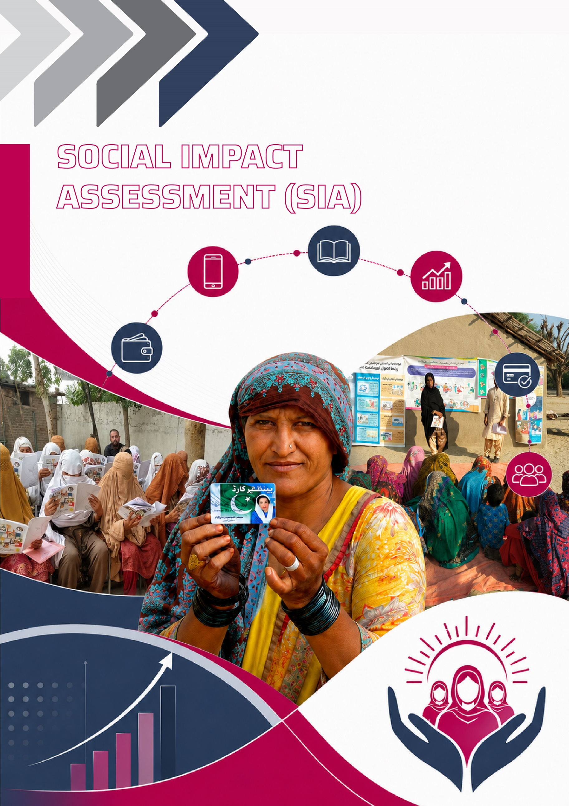

SOCIAL IMPACT ASSESSMENT (SIA)
This chapter presents the qualitative findings of the Social Impact Assessment (SIA) conducted as part of the impact evaluation of the Digital and Financial Literacy Training (DFLT) for BISP beneficiaries. Drawing on focus group discussions with treatment and control participants across Khyber Pakhtunkhwa, Punjab, and Sindh, the analysis explores how the training shaped women’s knowledge, attitudes, and behaviours related to financial management, digital capability, household decision-making, and environmental responsibility. By examining the pathways of change as well as the persistent structural barriers affecting low-income women, this chapter provides an in-depth understanding of the programme’s contribution to women’s empowerment and financial inclusion. The findings also highlight provincial differences, viewpoint from the men of the families, perceived benefits, and participants’ recommendations, offering valuable insights to inform the future scale-up and refinement of digital and financial literacy interventions within Pakistan’s social protection ecosystem.

Impact of Digital and Financial Literacy Training (DFLT): Evidence from Social Impact Assessment- Key Thematic Findings

Participant Experiences with the Training
Across all three provinces, women in the treatment groups described the Digital and Financial Literacy Training (DFLT) as a meaningful and accessible learning opportunity. Despite entering the programme with limited expectations, the majority reported that the training environment was respectful, well organized, and beneficial. Others expressed that the sessions “made sense” and that the content was “very helpful”.
However, logistical challenges were reported in several locations. Women in Punjab and Sindh noted issues with crowding and long waiting times, particularly on days when multiple beneficiary groups were called simultaneously. “There was a lot of crowding,” one woman observed, echoing a common experience across provinces. Timing of sessions was also cited as a barrier for women managing household and caregiving responsibilities. Participants suggested morning sessions or dual shifts to ease the burden:
“The time issue was big… morning or evening shifts would help.”
In contrast, women in control groups often had little or no awareness of the training. Many heard about it only indirectly or after it had concluded. This lack of outreach highlights gaps in programme communication, limiting equitable access to knowledge-building opportunities.
Overall, treatment participants viewed the training as a rare space for learning and engagement. Many women expressed that it targeted low-literate women with practical, contextualized information.

Knowledge Gains in Financial and Digital Literacy
Increased Knowledge of Financial Literacy and Budgeting
The training contributed to significant knowledge increases in budgeting, expenditure planning, and basic financial concepts. Across provinces, treatment participants were able to articulate the difference between essential and non-essential expenditures and understood the purpose of setting aside money for bills and groceries. Many shared that they now consciously think about prioritizing expenses.
Participants also reported improved awareness of banking processes, account opening, and the benefits of saving through formal means. Women described learning where money should be deposited, how it can be withdrawn, and why bank accounts provide security.
This was in contrast to control participants who displayed limited knowledge of budgeting and formal financial tools. Their responses focused primarily on financial strain. This contrast indicates a clear programmatic effect on increasing participants’ financial concepts and awareness.
Enhanced Digital Capabilities
Treatment participants demonstrated increased familiarity with mobile money, ATM usage, and digital transactions, even where actual usage was limited. Across focus groups, women recalled being taught how to send money through shops, use basic features such as mobile calculators, and understand ATM functions. While most participants had not yet used these tools independently, often due to lack of smartphones, literacy constraints, or male gatekeeping, they expressed confidence in their ability to do so in the future.
Control participants, however, showed very low baseline understanding of digital financial tools, with some stating, “I don’t know what an ATM card is.” This further underscores the programme’s contribution to digital knowledge, even if behavioural uptake remains gradual.

Behavioural and Attitudinal Change
Savings Practices
Behavioural change in savings was evident across treatment groups. While many women remain financially constrained, several reported saving small amounts and practicing the habit of setting money aside. Even if it was one to two hundred rupees, participating women considered it as a mark of success.
In some cases, financial planning extended to small investments. A participant in Sindh noted,
“I purchased a young buffalo as part of my financial planning after the training.”
Such examples demonstrate emerging shifts toward long-term thinking, even among low-income households.
Digital Behaviour
Although digital transactions had not significantly increased post-training, the fundamental barrier was practical access rather than resistance. Participants described limited opportunities to apply learning due to lack of smartphones, absence of personal bank accounts, or reliance on male household members for transactions. The shift, therefore, is considered primarily cognitive rather than behavioural at this stage.
Environmental Responsibility
Messages related to climate change, water conservation, and waste management were among the more readily adopted behaviours. Women described reducing plastic use, disposing waste more responsibly, and encouraging children to change habits in limited capacities. One participant shared that she had “started thinking more about plants and plan to start planting them soon.” This impact became more apparent when compared against the control participants showed limited awareness of environmental concepts.

Empowerment, Decision-Making, and Social Norms
The training contributed to shifts in women’s perception of their roles in the household as well as their confidence in contributing to financial decisions. Many treatment participants reported joint decision-making on expenditure and household needs. However, adherence to traditional gender norms persisted in some households, with women explaining that financial matters remained under the full control of their husbands. The training’s emphasis on gender equality resonated strongly across provinces. Women appreciated learning that sons and daughters have equal rights to education and opportunity, noting that
“There should be no difference between them.”
Several women also described enhanced self-confidence and the ability to share knowledge with others. Such reflections suggest an emerging sense of agency, with women viewing themselves as active contributors to household and community-level learning.
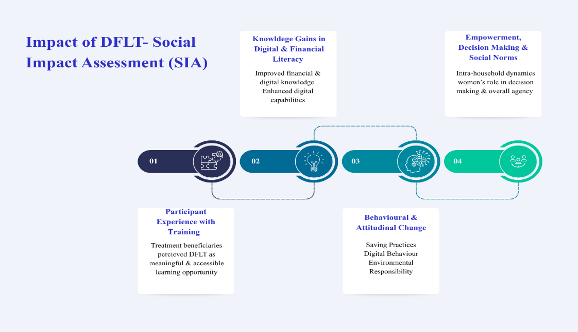
Fig 61:

Persistent Barriers to Impact
Despite notable progress, several structural and social barriers hindered full utilization of new skills.
- Structural Barriers
Low income remains the most significant constraint, limiting both savings behaviour and formal financial access. Many participants stated that they simply “do not have enough to save.” Additionally, it was noted that limited access to smartphones restricted digital learning. As one participant noted,
“We don’t need one. Our income is not sufficient to justify buying a phone.”
- Mobility and Household Responsibilities
Women across Punjab and Sindh cited time constraints due to caregiving, household chores, and informal labour commitments. These responsibilities restrict attendance at trainings and limit opportunities to practice digital skills.
- Fear and Misconceptions
Misinformation about the consequences of opening a bank account or participating in the BISP savings scheme was widespread, particularly among control participants. Many feared their benefits would be discontinued if they saved money.
- Limited Practical Exposure
Although conceptual understanding improved as a result of trainings, many women had not yet independently used digital financial tools.
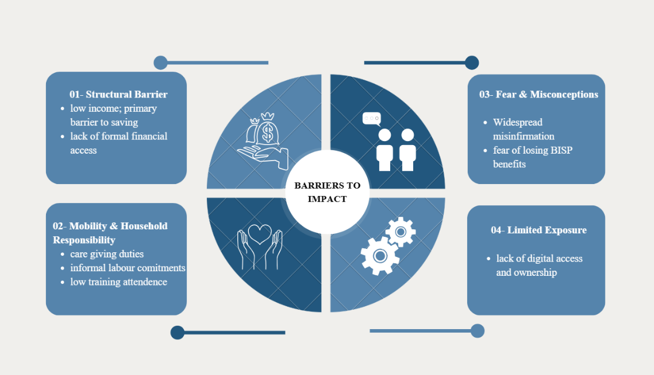
Fig 62:

Differences Between Treatment and Control Groups
The qualitative data demonstrates clear divergence between treatment and control groups in both knowledge and behaviour.
- Treatment participants consistently articulated greater understanding of savings, budgeting, ATM use, mobile accounts, digital fraud awareness, and environmental responsibility. They also described beginning to apply basic saving behaviours and sharing learning with others.
- Control groups, meanwhile, displayed little awareness of financial planning, digital tools, or environmental concepts. Their responses focused primarily on everyday financial hardship, limited knowledge, and lack of exposure.
- Spillover effects were notably stronger among treatment participants. Many shared the booklet and videos with neighbours and children. As one participant shared,
“Our children have seen the handbook… we shared this with family.”

Provincial Variation in Experiences
Table 10:
Khyber Pakhtunkhwa | Punjab | Sindh
KP participants demonstrated strong recall of budgeting, climate, and digital literacy messages. Even where usage remained limited, awareness was high. Climate-related behavioural shifts, particularly in waste reduction, were prominent. | Punjab participants faced more mobility and time-related challenges. Women emphasized the burden of housework, caregiving, and daily labour, which constrained both attendance and uptake. Interest in vocational and income-generating skills was highest in this province. | Sindh participants showed strong engagement with both the training videos and the booklet. Knowledge retention was relatively high. However, limited access to smartphones and formal financial services hindered practical uptake of digital financial behaviours.

Insights From Lateral Stakeholders - Community Men & Trainers

Trainers Delivering the DFLT Programme
The trainers responsible for delivering the Digital and Financial Literacy Training (DFLT) provided valuable insights into the operational realities of implementing the programme on the frontline. Their experiences underscore both the dedication of field staff and the structural challenges that shape programme delivery.
Challenges:
- Across interviews, trainers consistently identified mobilization of beneficiaries as the most significant challenge, where ensuring attendance required persistent outreach. Many women faced genuine barriers including limited mobility, lack of transport, childcare responsibilities, and household demands. As a result, trainers often contacted double the number of targeted participants in order to meet daily attendance requirements.
- The second major challenge was related to venue instability and insufficient facilities. Trainers described working in cramped or unsuitable settings, frequently experiencing last-minute venue changes that disrupted both preparation and learning continuity. Basic needs such as seating, water, electricity, and ventilation were not always guaranteed, with heat and power outages compounding difficulties in summer months.
Strengths:
Despite these constraints, trainers demonstrated strong commitment to ensuring an inclusive, supportive learning environment.
- They adapted content into local languages and used real-life examples to make concepts accessible.
- Beyond the curriculum, trainers frequently responded to women’s broader information needs, supporting them to understand birth registration, BISP program entitlements, and available financial services.
- Trainers proposed several improvements, including dedicated, consistent training venues at Union Council level, longer assignment periods in each location to build rapport with communities, and stronger mobilization support.
- They also highlighted the importance of skill-building and livelihood pathways, noting that many women explicitly asked for opportunities to earn income. Women frequently inquired about “how to get a job” or whether they could “set up a canteen” at the training venue, reflecting a strong aspiration for economic participation.

Perspectives of Male Household Members
Focus group discussions with male household members in Abbottabad offer an important lens into familial dynamics, gendered decision-making, and household attitudes toward women’s participation in DFLT. Their accounts demonstrate a generally positive perception of the programme, while also highlighting ongoing gender norms that influence women’s financial autonomy.
Most men were aware that their wives or mothers had attended the two-day training, although not all women discussed the training content at home. Some men reported that their wives shared key lessons on budgeting, money management, and ATM usage. Others stated that their wives had become more prudent spenders and increasingly encouraged disciplined financial habits within the household. In contrast, several men acknowledged that their wives did not discuss the training at all, illustrating variation in intra-household communication and women’s comfort levels in asserting new knowledge.
Men described a wide spectrum of involvement in household financial management. In many cases, husbands or male relatives handled all financial transactions, including ATM withdrawals, money transfers, and major purchases. However, several men reported more collaborative patterns, with wives preparing the household budget or planning purchases while men executed the transactions. Men also described observable behavioural changes among women post-training. Several noted increased independences. Others pointed to improvements in savings behaviours and financial discipline.
Importantly, men expressed strong support for continuation and expansion of the training, with many suggesting that additional days or extended sessions would be beneficial. They also endorsed women’s access to bank accounts and mobile money accounts, clarifying that they held “no objection” and that such services would be useful, especially in households where men migrate for work.
When asked about future training needs, men emphasized topics such as skill development, home-based income generation, investment of small amounts, child upbringing, and health and hygiene. Several highlighted the need for programmes enabling women to upgrade livelihood skills, for example, improving sewing abilities or supporting home-based retail.
The perspectives of male household members reveal an encouraging openness toward women’s learning, and recognition of the tangible benefits of DFLT for household financial management. At the same time, their accounts reaffirm that structural and social norms continue to limit women’s independent financial agency. Strengthening male engagement, through sensitization, joint sessions, or informational outreach, may further enable supportive environments that sustain women’s digital and financial empowerment.

Participant Recommendations for Programme Strengthening
While most participants described the training as sufficient and useful, several recurring recommendations emerged across focus groups:
Flexible Scheduling
Women strongly recommended offering morning or dual shifts to accommodate domestic responsibilities. Multiple participants expressed that flexible scheduling would help in increasing attendance.
Enhanced Skill-Building Opportunities
Participants expressed a desire for vocational skill development, such as embroidery, stitching, or beauty services, within or alongside DFLT.
Inclusion of Vulnerable Women
There was an urgency in the expressed need to include more vulnerable women in future cohorts. Several women emphasized the need to extend training to widows, isolated women, and those unable to leave home.
More Hands-on Digital Practice
Participants requested practical demonstrations of ATM use, mobile wallet registration, and live simulations of digital transactions to build confidence and reduce fear.

Key Takeaways from Social Impact Assessment SIA
The qualitative findings from this Social Impact Assessment illustrate that the Digital and Financial Literacy Training (DFLT) has generated meaningful and multidimensional shifts in knowledge, attitudes, and behaviour among BISP beneficiary women. Across Khyber Pakhtunkhwa, Punjab, and Sindh, participants consistently reported enhanced understanding of budgeting, savings, digital tools, and environmentally responsible practices. Although structural barriers such as low income, limited smartphone access, and restricted mobility continue to constrain the full realization of digital and financial literacy, the programme successfully laid foundational skills that women can build upon over time.
The training was also found to contribute to women’s sense of confidence and agency. Participants increasingly expressed readiness to make or influence household financial decisions, challenge gendered norms around education, and share new knowledge with other women and children. These shifts, while gradual, indicate a strengthening of women’s roles within their families and communities. At the same time, the experiences of control groups reaffirm the persistent knowledge gaps that exist in the absence of such interventions.
The analysis also highlights the important role of frontline trainers, whose commitment, adaptability, and community rapport have been central to successful programme delivery despite logistical challenges. Their perspectives underscore the need for more stable infrastructure, predictable schedules, and integrated livelihood components to support and amplify the impact of future cohorts.
Equally critical are the voices of male household members, who generally expressed support for women’s participation and recognized the value of the training for household financial management. Their openness to women’s increased independence and decision-making presents an encouraging entry point for deeper male engagement strategies, which could strengthen the enabling environment for women’s digital and financial empowerment.
Overall, the qualitative findings demonstrate that DFLT is not only building knowledge, but also catalyzing attitudinal change, encouraging dialogue within households, and positioning women as more informed and confident contributors to financial and social decision-making. Strengthening programme delivery, expanding practical digital components, and integrating skill-building and male engagement can further enhance the programme’s long-term sustainability and relevance. Collectively, these insights provide clear direction for scaling and refining digital and financial literacy initiatives within Pakistan’s broader social protection architecture.

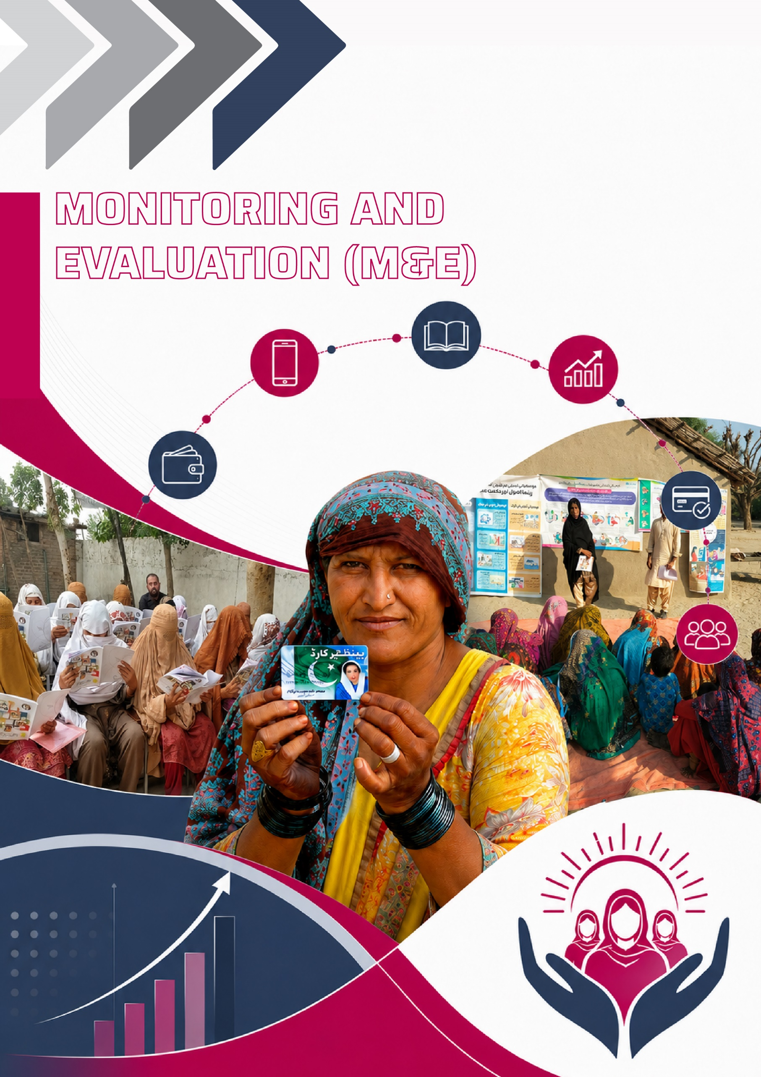

MONITORING AND EVALUATION (M&E)
This chapter entails the outcomes and findings from the robust Monitoring and Evaluation of the trainings conducted under Digital and Financial Literacy Training (DFLT) Phase-1. Section 1 laid the framework for the operational design and methodology or more appropriately the process adopted to facilitate the seamless M&E activities; Section 2 sets out the main parameters closely observed during on-ground monitoring; Section 3 analyse the quantitative data for key insight across the main thematic areas; and Section 4 list down the challenges and issues faced during the course of conducting M&E operations.

M&E Operational Design and Methodology
The thorough Monitoring and Evaluation (M&E) of the Digital and Financial Literacy Training (DFLT) was conducted across 04 provinces to ensure that the training adheres to established standards and achieve its desired outcomes. To establish this, a detailed and holistic operational design and methodology was adopted which comprehensively gauged the program's impact on enhancing digital and financial capabilities of the beneficiaries. This M&E process encapsulated the spot check monitoring of the trainings under the roll out of DFLT Phase-1 by the M&E coordinators at SDPI as well as the local evaluators hired in each province for full day in-field monitoring. Broadly, the M&E phase was structured into two key dimensions; the Process of Monitoring and Evaluation and the Parameters used to assess it. This approach allows for evidence-based decision making, ensuring that future scaling up of program is informed by the nuanced understanding of the beneficiaries.

Process of M&E
Geographical Scope and Area Breakdown
The DFLT Phase-1 was implemented nationwide across 4 provinces i-e Punjab, Sindh, Baluchistan and KP. Out of the total districts of intervention, the 30 districts were selected for the M&E across the 4 provinces, each ensuring equitable outreach to urban and rural union councils. Following is the distribution of the districts selected for M&E across 4 provinces;
- Punjab (16 Districts): Wazirabad, Hafizabad, Sialkot, Gujranwala, Gujrat, Rawalpindi, Chakwal, Bahawalpur, Sargodha, Jhelum, Sheikhupura, Multan, Okara, Lahore, Talagang, Faisalabad.
- Sindh (5 Districts): Shaheed Benazirabad, Malir, Khairpur, Sukkur, Karachi Central.
- Baluchistan (4 Districts): Killa Abdullah, Killa Saifullah, Quetta, Khuzdar.
- Khyber Pakhtunkhwa (KP) (5 Districts): Mardan, Nowshera, Peshawar, Karak, Dera Ismail Khan.
The figure below provides the visual illustration of all the above-mentioned districts from the respective provinces, plotted on the national map of Pakistan.

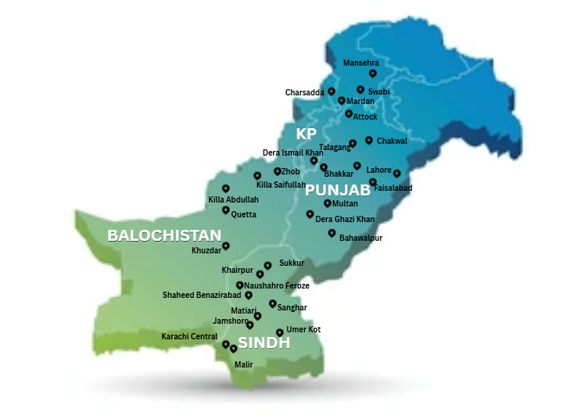
Fig 63: Selection and Profiling of M&E Evaluators
For the purpose of conducting and overseeing the M&E activities/operations, a pool of qualified and skilled evaluators were selected through the well-established selection process, ensuring procedural compliance and transparency. The primary selection criterion was a minimum of 16 years of educational attainment to uphold the rigorous standard of monitoring and data collection. Furthermore, to overcome the language and cultural barriers, only local evaluators with diverse educational backgrounds were chosen for each region.
Capacity Building: Training of M&E Evaluators
All the selected evaluators underwent a comprehensive training program to ensure they are well equipped with necessary tools, protocols and ethical guidelines for field monitoring and quality data collection. The training mainly focuses on following components;
- Skill Development: Techniques for effective data collection, observation, interpersonal communication, and on-the-spot problem-solving.
- Performance Assessment Form: A detailed and comprehensive orientation of the standardized performance assessment form, which helped grasp the core and fundamental aspects/dimensions it aimed to capture.
- Digital Tools: Practical, hands-on training in using the Survey_CTO application for accurate data capture, real-time data submission, and GPS-based location verification.
- Quality Assurance: Clear guidelines on maintaining data integrity, including cross-verifying information, identifying and resolving inconsistencies, and conducting necessary follow-ups with trainers and beneficiaries.
Overall, the purpose of the training of evaluator was to define the clear roles, familiarity with the data collection App and adherence to established protocols regarding field engagement and responsiveness to community dynamics.
Coordination, Communication, and Evaluation Process
A multi-tiered coordination structure was established to streamline coordination and communication, and ensure the smooth execution of M&E activities. The figure demonstrates the hierarchical setup that shows the structural flow of coordination and communication across different operational levels.
- National Coordinator: The coordinator was assigned to use a spreadsheet provided by BISP to get details about the trainer and training venues. Afterwards, they assign the venues and relay the necessary information to the respective provincial teams.
- Provincial Coordinators: They were designated to guide the evaluators, provide region-specific assessment probes, and acted as the primary link between the national coordinator and the monitoring team on field.
- Evaluators: The evaluator were at the core of the M&E process. They have been instructed to contact the trainers a day in advance to confirm locations, conduct on-site assessments, follow structured evaluation probes (e.g., taking photos with specific prompts and sharing real-time updates), and document evaluation forms using Survey_CTO.
- SDPI Monitoring Team: A dedicated team at SDPI headquarter was tasked to track incoming data in real-time through the Survey_CTO dashboard, ensuring data quality, accuracy, and monitor accountability.
The entire communication and coordination was facilitated through dedicated provincial WhatsApp groups, allowing for efficient coordination and real-time updates.
Data Collection and Management
The data collection was done using two primary digital forms, namely; M&E Training Observation Form and Syllabus Content Form, integrated into the Survey_CTO application.
- MNE Training Observation Form captured qualitative and quantitative data on the training environment, trainer performance, and participant engagement.
- Syllabus Content Form provides a checklist to verify which specific concepts from the curriculum were covered during the session.
All submitted data was instantly uploaded to the SDPI server, populating the live M&E dashboard enabling real time visibility. This live M&E dashboard was designed and maintained in the Survey_CTO Software for the daily status; publishable data; enumerator output and provincial output. This ensured immediate analysis and oversight, allowing for timely decision making and responsive action.

Parameters Of M&E
The M&E process established a comprehensive, performance-based approach encapsulating the range of parameters to ensure the quality of the training program. These parameters extend beyond just measuring the beneficiary knowledge gains or other outcomes and systematically evaluate the training design, delivery, logistics, and the overall learning environment to ensure the alignment with program objectives and participant’s needs.
The key parameters observed are;
- Quality of Training
This involved assessment of the clarity, coherence and relevancy of training content in accordance with the designed curriculum. This parameter focused on evaluating whether the training material was accessible, contextually appropriate, culturally sensitive and adaptable to diverse comprehension styles. Moreover, the effectiveness of training handbooks, wall posters and other supporting materials were reviewed to ensure they reinforced the key concepts and enhance retention.
- Trainer Competence and Delivery
This parameter is the most crucial as the trainer competency is at the core of entire DFLT initiative. The trainer assessment was done on the basis of subject knowledge, communication skills, facilitation techniques, and ability to foster participant engagement. The particular attention was given to the training methods employed, interactivity, responsiveness to participants/beneficiary’s needs and adherence to the scheduled agenda. The structured data collected captured the qualitative and quantitative insights on the overall instructional effectiveness and training delivery.
- Participant Engagement and Learning Outcomes
The engagement level was evaluated on the basis of observation of participation, interaction, collaborative learning and responsiveness during session over the course of two days. Further, the indicators such as comprehension, retention rates, perceived training effectiveness were also analysed to determine the level of proposed intended objective being met.
- Logistics and Program Coordination
A structured oversight/monitoring of the logistical arrangement was done to evaluate the resource allocation, scheduling efficiency, and overall coordination. Moreover, the suitability of training venue, accessibility of training material, flexibility in the training schedule and the availability of technical and administrative support were examined to ensure the smooth implementation process aligned with the beneficiary convenience.
- Learning Environment and Infrastructure
The overall learning environment was the most important determinant of training effectiveness. Its key parameter included access to digital tools, internet connectivity, physical infrastructure, and a distraction free setting. An interactive and supportive learning community proved to be an essential component to participant comprehension and sustained engagement.
Fig 64:

Key Findings From M&E
The quantitative data collected during the M&E process was plotted and synthesized to have valuable insights across the key parameters of M&E. The findings are;
Quality of Training
The M&E evaluators observed the training and assessed its quality as the composite analysis across three dimensions of clarity of content, relevance of content and accessibility of content. The graph below indicates on average the monitored trainings demonstrated approximately 60% clarity of content. This suggests that while some concepts have been sufficiently explained, the others were still difficult for the participant to grasp completely. Similarly, the monitored trainings successfully delivered the 66% relevancy and accessibility of content, implying that the designed curriculum was contextually appropriate and suitable for target audience. Overall, the quality of training was moderately high with the clarity, relevance and accessibility of content, all indicators noted to be above the 50% mark.
Trainer Competence and Delivery of Training
The trainer competence and the delivery of training was assessed across the range of indicators namely; subject knowledge, communication skills, training methods and adherence to schedule. On average 71.6% of evaluators rated that the trainers were sufficiently knowledgeable and had strong command of the subject matter. 69.7% of the evaluators argued that the communication skills of the trainers were also effective as they were to convey complex ideas clearly. Regarding training methods and hands-on activities, 64.96% of sessions were noted to follow structured approach with interactive and learner centered techniques. Whereas there were gaps in terms of adherence to schedule, as it was observed that trainers struggled to fully adhere to planned schedules, indicating challenges with time management and pace. The data indicates that 53% of the training were observed to have followed the structured schedule.

Participant Engagement Level
The graph 1 shows the participant engagement level across different selected districts of M&E. The analysis indicates that districts namely; Shaheed Benazirabad, Malir and Karachi Central from Sindh, along with Sargodha and Multan from Punjab demonstrate exceptional (100%) engagement level. This reflects a high degree of participant interaction with the training content and suggests strong alignment between the delivery approach and participant’s learning needs and interests.
On contrary, the districts such as Khuzdar (20%) and Khairpur, Sheikhupura & Swabi (40%) recorded the engagement level fall below the halfway mark (50%). These comparatively lower rates point toward potential gaps in delivery mechanisms, facilitation techniques, or contextual adaptation of the training, warranting further examination and tailored improvements.
Figure 67:
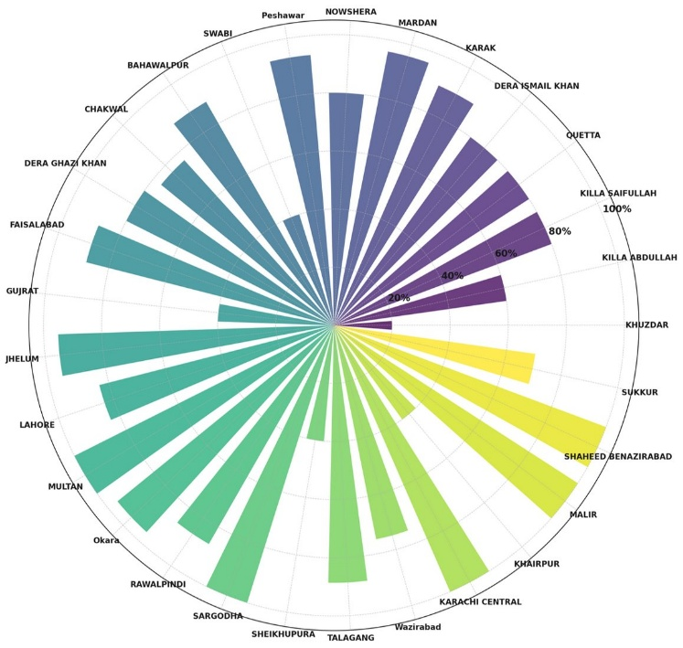
Participant Retention Rates
Retention Analysis: Districts with Perfect Retention
The on-ground monitoring and evaluation of the trainings pointed out that the retention of the participants on the Day 02 of the training was notable operational challenge to account for. The graph below displays the retention analysis of the districts with perfect retention (no dropout between Day 01 and Day 02) on day 02 of the training across multiple trainings. The graph shows that districts, Bahawalpur and Faisalabad stand out as high performing districts having conducted multiple sessions with perfect retention Difference=0.
This retention reflects trainer effectiveness, well managed sessions and strong participant engagement. Similarly, some other districts including, Chakwal, Mardan, Okara, Wazirabad, Jhelum, Khairpur and Nowshera had the perfect level of retention across 2-3 monitored training sessions. While, the districts namely, Karak, Killa Abdullah, Killa Saifullah, Rawalpindi, Shaheed Benazirabad, Sukkur and Talagang recorded perfect retention in the trainings monitored.
Fig 68: Retention Analysis: Districts with Critical Retention Issues
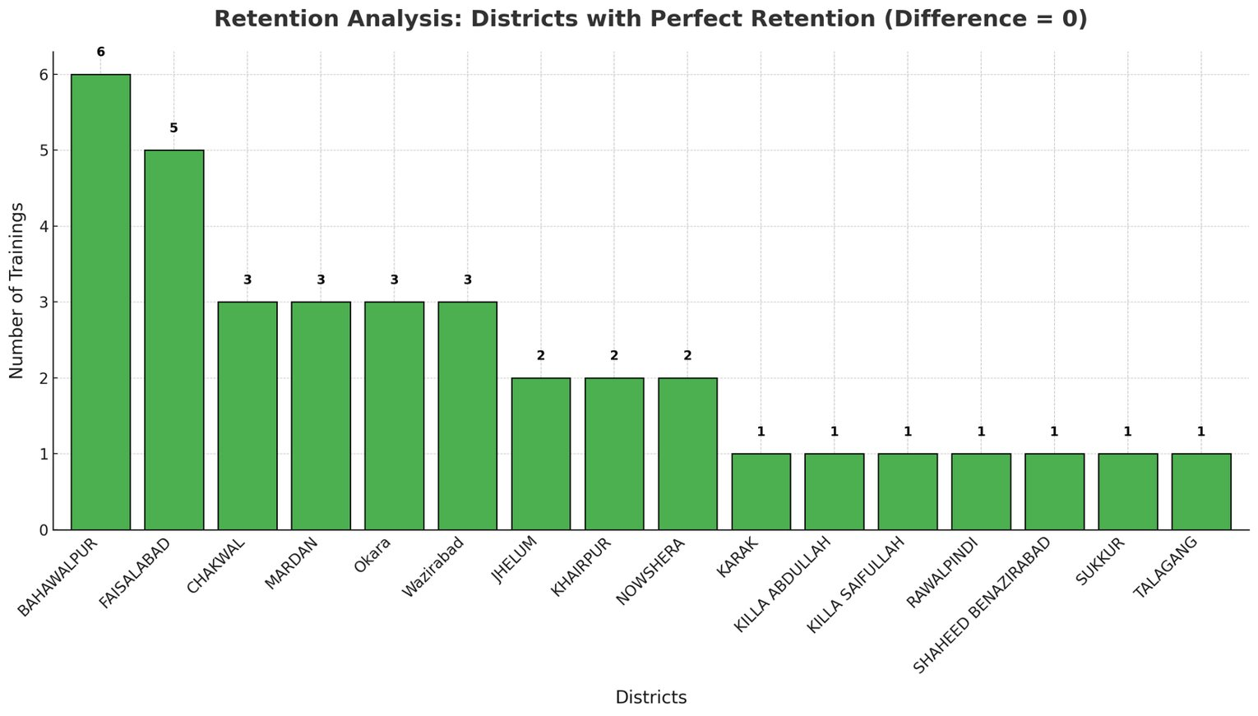
The detailed retention analysis was conducted to identify the districts that exhibit critical participant retention issues. The difference was calculated for the participant present on day 01 and day 02. If the difference is 0, it implies perfect retention as discussed above. However, there were instances of Negative differences and Positive differences
- A Negative Difference imply the poor retention where the participant number drop on the day 02 of the training due to range of reason. If the negative difference or the decline is five or more than 5 (≥ 5) it was considered as critical retention issue, indicating substantial dropout that requires immediate attention.
- A Positive Difference implies an increase in the attendance on Day 02, suggesting the presence of new participants to inflate the overall attendance figure of the trainer.
The graph highlights the districts with the critical retention issues. Lahore emerges as the most concerning case with the frequent instances of critical dropout in its monitored trainings. While all the other districts, namely Dear Ghazi Khan, Khairpur, Karachi Central, Multan, Okara and Sheikhupura, each recorded a critical retention issue in only one of the monitored trainings.
Fig 69: Training Effectiveness; Cross-Case Analysis of Provincial and District Wise Average Training Scores

Province Wise Average Training Scores
The graph presents the province level average training scores across Punjab, Sindh, KP and Baluchistan, which are quite modest with the averages falling between the range of 58-65%. Province wise, Punjab recorded the highest provincial average of 65.2%, indicating comparatively stronger and consistent training delivery mechanism. Followed by Punjab, is the KP with average score of 64.7%, reflecting stable performance. Then comes Sindh with the score of 60.9%, which exhibits modest performance but the low performing districts lower its aggregate scores. Lastly, Baluchistan records the lowest provincial average score of 58%, which is attributable to the underperformance of its certain districts. This provincial analysis suggests that the difference is not that extreme, and the training effectiveness is moderately consistent nationwide. Also, it has been observed that the effectiveness of training was highly localized and dependent on the effectiveness of trainer.
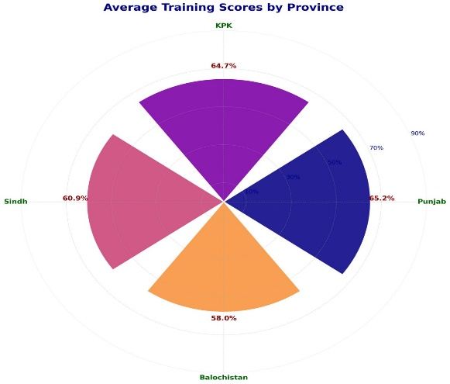
Fig 70: District Wise Average Training Scores
The graph below illustrates the comparative district wise analysis of average training scores across Punjab, Sindh, Baluchistan and KP, offering a cross-case perspective on training effectiveness and the provincial performance patterns.
- The performance in Punjab exhibits noticeable variability. Sargodha emerges as the leading district with a score of 92%, reflecting strong training delivery mechanisms and effective participant engagement. In contrast, Chakwal records the lowest score at 36.7%, indicating substantial challenges related to training quality, facilitation, contextual adaptation, or participant responsiveness. This intra-provincial variation suggests the need for targeted corrective measures in lower-performing districts while documenting best practices from high-performing ones.
- In Sindh, Karachi Central demonstrates high performance with a score of 92%, indicating well-executed training delivery and strong learning outcomes. Malir, however, stays at the bottom with the lowest score of 44% in the province. While this signals areas for improvement, the overall training outcomes are relatively more stable in Sindh as the minimum performance level remains comparatively higher than Punjab’s lowest-performing district.
- Baluchistan presents the most extreme variability, where Quetta tops the chart with a perfect score of 100%, reflecting exceptional training effectiveness and participant satisfaction. Conversely, another district, Khuzdar records a significantly low score of 28%, highlighting serious gaps in delivery, engagement, or enabling conditions. This sharp contrast underscores uneven program implementation and suggests the influence of contextual, logistical, or capacity-related factors within the province.
- In KP, performance appears relatively balanced compared to Baluchistan. Mardan leads with 88.8%, demonstrating strong training outcomes, whereas Dera Ismail Khan records the lowest score at 44%. Although the disparity is less pronounced than in Baluchistan, the gap still indicates the need for strategic interventions to ensure greater consistency across districts.
Fig 71:
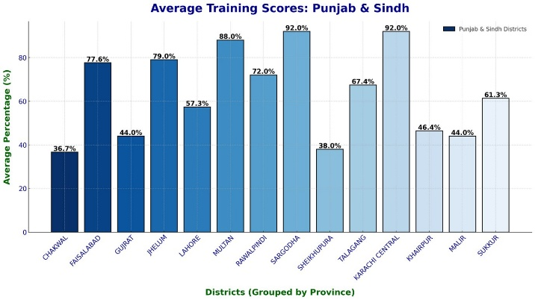 | 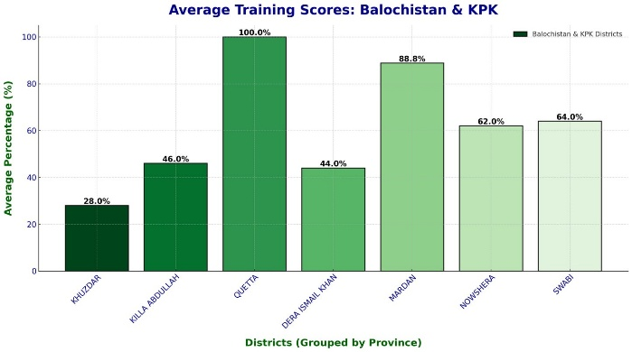

Quality of Training Venue
The quality of training venue is important, as it directly correlates with participant engagement, understanding and retention. Graph 04 revealed some significant disparities across provinces in terms of quality of training venue. The quality of training venue is assessed based on three parameters i-e, adequacy of space, comfort level of space and availability of drinking water.
In terms of Adequacy of Space, Baluchistan records the highest score (5/5), indicating that the venues were spacious and sufficient to accommodate participants. Followed by KP (4.2), Sindh (4.1) which had adequate space. While Punjab scores comparatively lower score (3.7), indicating the absence of optimally arranged space.
However, when it comes to the Conduciveness and Comfort of The Available Space, Baluchistan moves to the lowest score (3/5), reflecting that the spacious space failed to create a comfortable and supportive learning environment (such as absence of necessary infrastructure, seating and other). KP gets the highest score (3.9/4), indicating the availability of most comfortable and training friendly space for training. While Punjab (3.3/5) and Sindh (3.4/5) show the moderate scores in terms of comfort of the selected training venue, suggesting room for improvement in seating arrangement, ventilation and overall ambiance.
Lastly, for the Availability of Drinking Water, Baluchistan scored the lowest (2.7/5), reflecting a notable lag in the provision of basic facilities at training venue. The KP scores the highest (4.2/5), closely followed by Punjab (4.1/5) and Sindh (3.4/5).
These results resonate with the evaluators’ observations that repeatedly reported that poor venue quality which includes, overcrowding, no proper seating and poor ventilation directly led to reduced participant focus and willingness to return for the second day of training.
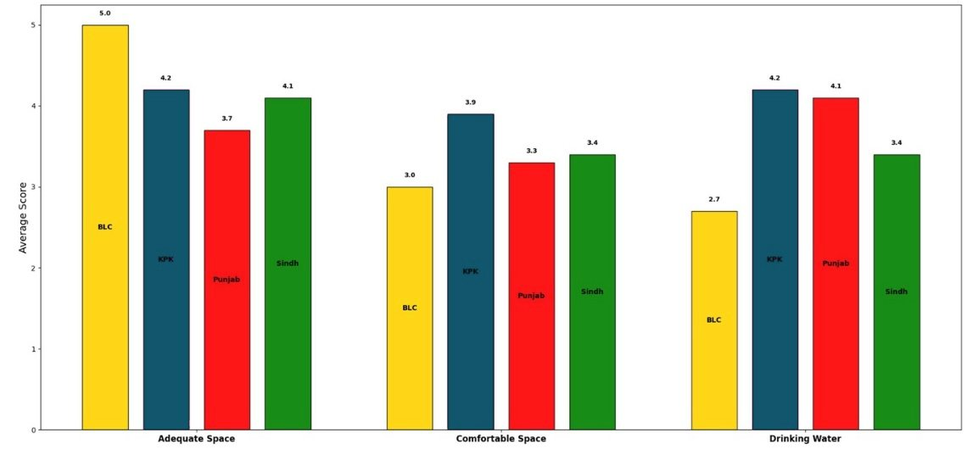
Fig 72:

Effectiveness of DFLT Handbook
The handbook provided during the training proved to be a critical resource, especially for uneducated participants. Graph 5 depicts 84.1% of beneficiaries agreeing or strongly agreeing on its effectiveness, indicating perceived usefulness and acceptance. Its simplified language, visualized illustration, storytelling and structured layout helped bridge the literacy gaps and reinforced the key learning concepts. It was observed that the districts with better handbook integration, retention rates & participant engagement were noticeably higher.
Role in Supporting Trainers: Additionally, the handbook also served as a complementary tool for trainer facilitation. In districts where trainer engagement was relatively lower, the handbook provided participants with an alternative and self-paced learning reference, partially compensating for facilitation gaps. This highlights its strategic value as both a pedagogical aid and a quality assurance mechanism.
Challenges in Utilization: Despite the overall effectiveness and positive reception of the handbook, several challenges were also reported that limits its utilization. Some participants reported difficulty in understanding certain visuals primarily due to insufficient localization and contextual adaptation. Further, the lack of guidance from trainers on how to effectively navigate and use the handbook reduced its potential.
On the other hand, the trainers reported the underutilization of the handbook in instances where it was not systematically integrated into the session plans as the distribution delays disrupted the timely use. Also, in districts with weaker engagement levels or suboptimal venue conditions, the handbook’s potential as an interactive learning tool was not fully realized.
Fig 73:
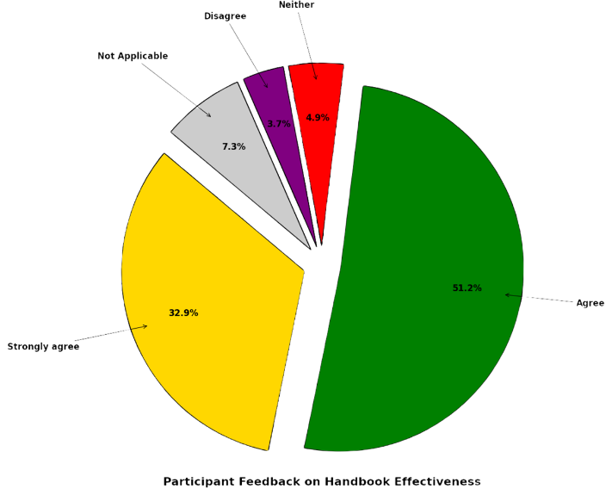

Challenges and Limitations
This section lists different types of challenges that were encountered during the monitoring and evaluation M&E of the DFLT. These challenges and limitations manifest at various levels;
Table 11: Multi-tiered Challenges
Beneficiary-Level Challenges | • Lack of Refreshments: The absence of water was a frequently cited issue, impacting comfort and engagement during long sessions.
Beneficiary-Level Challenges | • Insufficient Consent Building: In some cases, beneficiaries appeared to be present without a full understanding of the training's purpose.
Beneficiary-Level Challenges | • Cultural Barriers: Female participants were sometimes hesitant to speak or engage freely, especially in the presence of male staff.
Trainer-Level Challenges | • Logistical Burden: Trainers were responsible for arrangements like training venue, and subsequent seating, water and others. This operational responsibility, especially for female trainers, distracted from their ability to prepare and deliver high-quality content.
Trainer-Level Challenges | • Scheduling Conflicts: At certain times, BISP assigned some additional task and duties to the trainers which affected training schedules and led to sessions being rushed or postponed.
Trainer-Level Challenges | • Communication Barriers: The trainers used their personal phone numbers for mobilization and contacting beneficiaries. This proved to be an informal channel.
M&E Evaluator Level Challenges | • Dependence on Trainers: As it is the community-driven model, so the monitors/evaluators were reliant on trainers for training location and schedule details, making independent verification difficult.
M&E Evaluator Level Challenges | • Reaching Remote Locations: After the aforementioned issues, the communication from trainers sometimes led to significant delays for monitors in trying to locate training venues especially in remote areas.

The M&E framework effectively captured the DFLT’s strengths and weaknesses, revealing whether the training was delivered efficiently and effectively, thereby assessing the robustness of the curriculum and systematic operational and logistical challenges encountered. The variances observed in the training quality, engagement, and retention across districts were not random but directly linked to trainer burden, venue quality, and communication protocols. Overall, this M&E component proved to be an ideal in providing the real time feedback that allows for the taking up corrective measure and capture lesson learned for future programming.

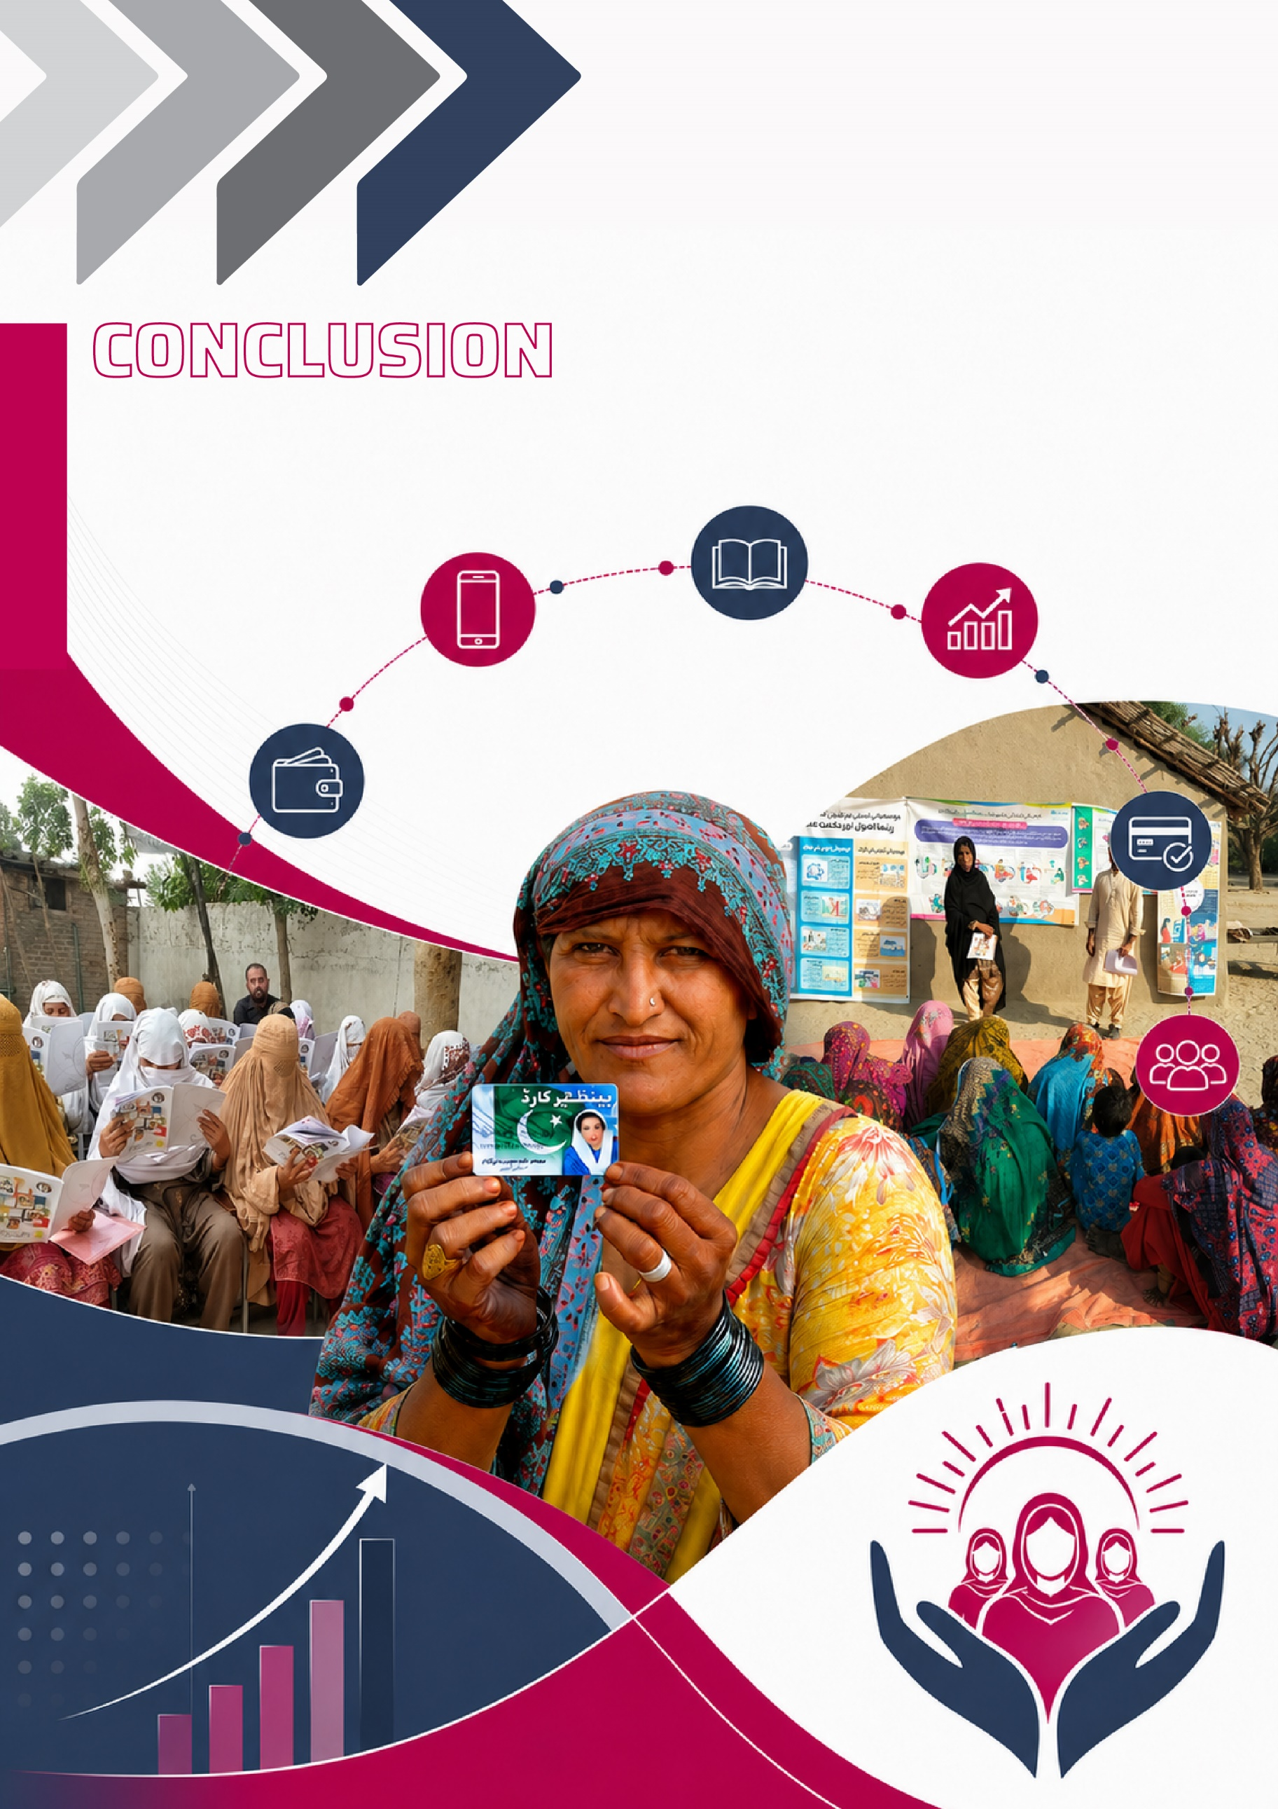

CONCLUSION
This study attempted to conduct the rigorous impact evaluation of the Digital and Financial Literacy Training on the BISP beneficiaries in Pakistan, with the focus on understanding the changes in the level of awareness and knowledge, behavioural implications and socio-economic outcomes that it intends to improve. For this purpose, it draws on the nationally representative sample spanning across four provinces including, Punjab, Sindh, Khyber Pakhtunkhwa and Baluchistan, while randomly assigning the participants to control and treatment groups. For the evaluation process, the systemic and comprehensive Baseline and Endline Survey was conducted to capture the pre-and-post training outcomes of the beneficiaries, establishing the final sample size of 4,802 unique beneficiaries. Following the Baseline Survey, the Digital Intervention was delivered to the treatment beneficiaries by segmenting them across multiple treatment arms. This intervention was introduced in addition to the physical training, with its effectiveness also evaluated at the End line. The analysis utilizes the robust empirical technique of Randomized Control Trial (RCT) and RCT Difference-in-Difference (RCT-DiD), complemented by qualitative insights derived from the Focus Group Discussion (FGDs). Additionally, the subsequent Monitoring and Evaluation (M&E) further strengthened the evaluation process by providing evidence on fidelity of implementation and the broader contextual factors influencing programme impact. Together, these approaches provide a comprehensive and triangulated understanding of the effectiveness of the DFLT programme and its underlying interventions.
The findings from the Exploratory Data Analysis EDA provide a preliminary insight on the programme’s impact, highlighting gains among the treatment beneficiaries and a clear shift from passive recipients to more informed and proactive agents. The observed patterns give early indication of effective adoption of the training and its interventions, improved institutional trust, greater inclination towards formal financial channels, and more informed digital adoption. In addition, participants demonstrated enhanced awareness of climate change risk and adaptive responses at individual and community level. These initial results point towards improved awareness and understanding on essential and foundational capabilities reflecting in the informed decision making and strengthened household resilience.
The quantitative findings consistently demonstrate that the DFLT programme and its interventions have been effective in building the foundational capabilities, especially in improving financial literacy, financial skills and digital competencies. The empirical estimates from the RCT across the various treatment arms as well as the RCT-DiD indicate strong and statistically significant improvement in the knowledge-based outcomes such as financial literacy, financial skills and phone related skills. Further the gains are observed in the improvements in the budgeting practices and the moderate increase in the savings. Despite some of the notable improvements, the magnitude of change in structural outcomes such as account ownership, amount of savings and sustained financial behaviour remains comparatively modest, suggesting that while knowledge acquisition is strong, the behavioural adoption is rather gradual and is constrained by other factors as well.
The multi-level and heterogeneity analysis also provides important insights into the distributional impacts of the 2-day training. The province wise analysis revealed that the interventions tend to create more substantial gains in the relatively underserved and underdeveloped areas in KP and Baluchistan, particularly in terms of improving awareness and skills. Whereas, on the other hand Sindh shows comparatively weak and less consistent impact, potentially attributable to the region-specific challenges. Among all the provinces, Punjab demonstrates more consistent and balanced progress across the key indicators, reflecting wider adoption of training and its content. Furthermore, the desegregation by other demographic characteristics like age and education, reveals that these individual characteristics significantly shape the program effectiveness, with relatively educated and younger participants showing greater improvements especially in digital and financial skills. Moreover, at the tehsil level the findings further unveil the localized and context specific variations, with certain areas showing substantial gains while other remain constrained by the barriers like limited access to digital infrastructure and financial services. Collectively, the findings emphasize that the impact of DFLT is not uniform and is mediated by the regional, socio-economic and individual level characteristics. Furthermore, the results are in line with the observations recorded during the robust Monitoring and Evaluation of the DFLT porgramme.
The findings from the Social Impact Assessment complement the quantitative findings and provide substantiative qualitative evidence of the programme effectiveness. It highlights that the DFLT is widely perceived as the meaningful and the accessible learning opportunity by the participants. It noted that training not only improved the capacity on key financial concepts like budgeting practices, expenditure planning but also enhanced the digital capabilities like ATM usage and mobile money. Moreover, it also provides evidence on the emerging behavioural and attitudinal change, including the improved saving habits indicating the gradual shift towards the forward-looking financial planning. While the increased awareness and willingness to adopt shows an important step towards digital inclusion, yet the real adoption remains more of cognitive than behavioural.
One of the key impacts of DFLT and its interventions is its role in the women empowerment, reflected through improved awareness, greater confidence in household decision making and an emerging sense of agency. While the traditional gender norms persist, there are early signs of shifting perception, supported by the generally positive views from the male household members as well. However, there are structural, institutional barriers limiting access and prevailing misconceptions and beliefs that restrict the full translation of gains into sustained behavioural and economic outcomes.
In sum, the Digital and Financial Literacy Training (DFLT) programme and its interventions has made significant stride in achieving its stated objectives, particularly building the foundational literacy and focusing on the most marginalized women. However, the transition from being aware and knowledgeable to sustained behavioural and economic outcome remain gradual and uneven, shaped by structural constraints and contextual realities. The findings from the impact evaluation highlight the importance of complementing training with the measures that address the potential barriers, strengthen digital and financial ecosystems, tailor approaches to local conditions and beneficiary characteristics. Moving forward, integrating livelihood opportunities, enhancing practical digital and financial inclusion, incentivizing saving practices, and advancing greater engagement at household and community level will be critical for amplifying the impact. In nutshell, the study provides the substantial evidence that DFLT proves to be valuable and scalable programme, capable of contributing meaningfully to financial inclusion, women empowerment, while also transforming social protection systems to become more adaptive in the wake of climate change, thereby advancing inclusive economic development in Pakistan.

Policy Implications
The findings of the impact evaluation of the DFLT provide some valuable insights to enhance the effectiveness of the pragramme and its interventions in the future scaleup. The set of recommendations below is rooted in the evidence and focuses on addressing the barriers and the tailor the interventions to better serve the targeted beneficiaries.
- Given the demonstrated effectiveness of the program, it should be expanded in terms of both scope and impact. The pertinent gap has been observed in the immediate and ultimate financial and digital inclusion of the beneficiaries despite the invoked awareness and knowledge. In the upcoming phases, the training should be paired with the subsequent digital wallet opening of the participants. This digital wallet opening should be institutionalized and offer guided support on the usage. In this way, the programme ensures the true digital and financial inclusion of the beneficiaries into formal financial channels.
- The results from the impact evaluation showed that while saving behaviour has improved, the magnitude remains low, indicating the need to introduce incentive and structure mechanism. In this regard, the co-contributory saving scheme model, similar to HSPS by World Bank should be introduced as the programme component. On one hand, the scheme would encourage savings by offering a matching contribution/incentive on the specified amount, while on the other hand it would bring the participants in formal financial systems as the savings will be retained. Moreover, adopting a systemic and structured approach could allow for linking these savings to a specific goal such as health, education, investment, thereby promoting more disciplined financial planning and encouraging retention for longer period of time.
- Limited digital connectivity and access (lack of phone ownership) remain as one of the key barriers to digital and financial inclusion. The policy effort is required to partnership with the telecom service providers for the low-cost connectivity and community digital access points. Simultaneously, sustained awareness is critical to instill the economic importance of digital tool, shifting perception from mere luxury to necessity in 21st century.
- The concepts like budgeting and investment are found to be relatively complex and difficult to understand. The training should incorporate the dedicated sessions with simplified examples, practical layman methods/techniques, accessible tools to help grasp it more appropriately. Also, the community driven mentoring and repeated exposure is crucial to help shift theoretical understanding into the sustained behavioural adoption.
- The effectiveness and impact of the Digital and Financial Literacy Training (DFLT) could be enhanced if it links the improved awareness and knowledge into livelihood and income generating opportunities, ultimately transforming these beneficiary women into productive economic agents. The policymakers should focus on introducing the livelihood programs such as; microcredit schemes, vocational training, cash for work under the DFLT stream, that will help enable the trained beneficiaries to apply the skills meaningfully. This alignment will strengthen the pathway from knowledge to economic empowerment.
- The initiative like DFTL essentially designed for the women, delivered by the women has proven to be effective in creating sense of agency and confidence among the women. Yet, advancing the women role in decision making requires shifting perceptions and addressing the structural barriers that limits the participation. Therefore, the future programming should focus on strengthening gender modules and include the engagement sessions for the men of the household, creating a community level sensitization.
- There is a demonstrated lack of awareness and understanding of the inevitable phenomena i-e climate change and its impact. This requires integrating climate change awareness modules in future programming with the focus on the consequences of climate change, Disaster Risk Reduction DRR, climate action and climate resilience.

REFERENCES
Babar, H. (2023). Fintech- a solution for financial inclusion and women’s economic empowerment? Qeios. https://doi.org/10.32388/af1eu0
Basnayake, D., Naranpanawa, A., Selvanathan, S., & Bandara, J. S. (2024). Financial inclusion through digitalization and economic growth in Asia-Pacific countries. International Review of Financial Analysis, 96, 103596. https://doi.org/10.1016/j.irfa.2024.103596
Calderone, M., Fiala, N., Mulaj, F., Sadhu, S., & Sarr, L. (2018). Financial education and savings behavior: Evidence from a randomized experiment among low-income clients of branchless banking in India. Economic Development and Cultural Change, 66(4), 793-825.
Custers, A. Experimental evidence from a financial literacy program for microfinance clients in Bhopal, India.
Dhungana, B. R. (2022). Financial Inclusion for Inclusive Growth in South Asian Nations: A Systematic Literature Review. Journal of Emerging Financial Markets and Policy, 1(2), 14–29. https://doi.org/10.4038/jefmp.v1i2.6
Ejaz, M., & Qayum, M. (2023). Financial Inclusion and Women’s Empowerment in Pakistan. Pakistan Journal of Humanities and Social Sciences, 11(4). https://doi.org/10.52131/pjhss.2023.1104.0715
EU. (2024). Estonia 2024 Digital Decade Country.
Jack, W., & Suri, T. (2011). Mobile money: The economics of M-PESA (NBER Working Paper No. 16721). National Bureau of Economic Research.
Kahina, D. I., Rokhimah, R., Hasrun, A., Masseni, M., & Sofia, S. (2024). Empowerment of Economy and Finance Through Digital Literacy Training in Sorong City. Teumulong: Journal of Community Service, 2(5), 254-263.
Karki, S. K., Andaregie, A., & Takagi, I. (2024). Impact of financial literacy training on the financial decisions of rural households in Nepal. International Review of Economics, 71(2), 149-173.
Kass-Hanna, J., Lyons, A. C., & Liu, F. (2022). Building financial resilience through financial and digital literacy in South Asia and Sub-Saharan Africa. Emerging Markets Review, 51, 100846. https://doi.org/10.1016/j.ememar.2021.100846
Koomson, I., Villano, R. A., & Hadley, D. (2020). Intensifying financial inclusion through the provision of financial literacy training: a gendered perspective. Applied Economics, 52(4), 375-387.
Koomson, I., Villano, R. A., & Hadley, D. (2021). Accelerating the impact of financial literacy training programmes on household consumption by empowering women. Applied Economics, 53(29), 3359-3376.
Koomson, I., Villano, R. A., & Hadley, D. (2023). The role of financial literacy in households’ asset accumulation process: Evidence from Ghana. Review of Economics of the Household, 21(2), 591-614.
Kumar, J. S., & Shobana, D. (2025). A Study on Digital Literacy and Rural Entrepreneurship: Evaluating PMGDISHA’s Contribution in Nagaland. Naveen International Journal of Multidisciplinary Sciences (NIJMS), 1(4), 54-65.
Kumar, S. S., & Jie, Q. (2023). Exploring the role of financial inclusion in poverty reduction: An empirical study. World Development Sustainability, 3, 100103. https://doi.org/10.1016/j.wds.2023.100103
Mabrouk, F., Bousrih, J., Elhaj, M., Binsuwadan, J., & Alofaysan, H. (2023). Empowering Women through Digital Financial Inclusion: Comparative Study before and after COVID-19. Sustainability, 15(12), 9154. https://doi.org/10.3390/su15129154
Mahmood, S., Shuhui, W., Aslam, S., & Ahmed, T. (2023). Financial Inclusion: Does it matter in Alleviating Poverty in Pakistan. Social Indicators Research, 169(3), 1125–1146. https://doi.org/10.1007/s11205-023-03200-y
Mas, I., & Kumar, K. (2008). Banking on Mobiles: Why, How, for Whom? Focus Note No. 48. CGAP
Mishra, D., Agarwal, N., Sharahiley, S., & Kandpal, V. (2024). Digital financial literacy and its impact on financial decision-making of women: Evidence from India. Journal of Risk and Financial Management, 17(10), 468.
Mishra, D., Kandpal, V., Agarwal, N., & Srivastava, B. (2024). Financial Inclusion and Its Ripple Effects on Socio-Economic Development: A Comprehensive Review. Journal of Risk and Financial Management, 17(3), 105. https://doi.org/10.3390/jrfm17030105
Mulili, B. M. (2022). Digital Financial Inclusion: M-PESA in Kenya. In Digital Business in Africa (p. Springer).
Mwanza, C. C., & Odoyo, C. O. (2024). IMPACT OF IMPLEMENTATION MODELS ON FINANCIAL INCLUSION AND RESILIENCE: A STUDY OF RURAL WOMEN IN ZAMBIA. Innovation, 7(4), 87-103.https://doi.org/10.52589/ijebi-lukire8o
Nawaz, F., Sajjad, A., & Farooq, M. W. (2023). Financial Inclusion (FI) Mediates the Relationship Between Financial Literacy (FL) and Women’s Economic Empowerment (WEE). Bulletin of Business and Economics (BBE), 12(3), 761–769. https://doi.org/10.61506/01.00118
Proscovia, N. R., Johnny, M., Robert, B., Diana, N., & Robert, K. (2021). Influence of informal financial literacy training on financial knowledge and behavior of rural farmers: Evidence from Uganda.
Qudsi, N. A., & Nurhayati, S. (2023). Basic Financial Literacy Training Program as a Rural Communities Empowerment in the Digital Economy Era. Aksara: Jurnal Ilmu Pendidikan Nonformal, 9(2), 997-1008.
Rajeev, V. R., Pillai, N. M., Radhakrishnan, A., & Bhavani, R. R. (2018). Evaluating digital India through national digital literacy mission in Kalliyoor panchayath. International Journal of Pure and Applied Mathematics, 119(15), 1943-1954.
Saeed, J., Maqsood, N., Shahid, T. A., Amir, H., Rehman, A. U., & Bilal, K. (2024). Impacts of Social Capital, Financial Literacy and Financial Inclusion on Economic Growth of a Primary Data Analysis: Evidence from Pakistan Special Focus on Listed Banks. Bulletin of Business and Economics (BBE), 13(2), 637–646. https://doi.org/10.61506/01.00373
SBP. (2024). National Financial Inclusion Strategy 2024-2028.
Showkat, M., Nagina, R., & Nori, U. (2024). Towards sustainable development: financial inclusion and women’s economic empowerment in India. Gender in Management: An International Journal, 40(2), 292–313. https://doi.org/10.1108/gm-05-2024-0229
Singh, S. (2024). Bridging the Digital Divide for Rural Women through Pradhan Mantri Adarsh Gram Yojana Scheme.
Steinert, J. I., Cluver, L. D., Meinck, F., Doubt, J., & Vollmer, S. (2018). Household economic strengthening through financial and psychosocial programming: evidence from a field experiment in South Africa. Journal of Development Economics, 134, 443-466.
State Bank of Pakistan. (2025, April 14). Pakistan Financial Literacy Week 2025 launched. https://www.sbp.org.pk/press/2025/Pr-14-Apr-2025-2.pdf
VINOD[, A. J. (2025). An Analysis of Pradhan Mantri Jan Dhan Yojana (Pmjdy): Financial Inclusion and its Impact on the Indian Economy. INTERANTIONAL JOURNAL OF SCIENTIFIC RESEARCH IN ENGINEERING AND MANAGEMENT, 09(02), 1–9. https://doi.org/10.55041/ijsrem41442
World Economic Forum. (2024). Why financial inclusion is the key to a thriving digital economy.
Yakubi, Y. A. Y., Basuki, B., Purwono, R., & Usman, I. (2022). The Impact Of Digital Financial Inclusion On Socio-Economic Development In Low-Income Countries. In Applied Econometrics and International Development 22 (2), 89-108, 2022.

Press Release-Ministry of Electronics and IT- Government of India
Dunning-Kruger Effect’
SurveyCTO is a secure and flexible digital data collection platform, widely employed for the purpose for the purpose of monitoring and evaluation. It offers online and offline data collection using digital devices such as mobile phones and tablets, with strong encryption and quality control features.

